**DECLARATION**

I declare that the work presented in this project titled “***Wellbeing: Personal Assistant***”, submitted to the Department of Engineering & Technology, Guru Nanak Dev University Regional Campus, Jalandhar for the award of degree of Bachelor of Technology in Computer Science and Engineering, is my original work. I have not plagiarized or submitted the same work for the award of any other degree. In case this undertaking is found incorrect, I accept that my degree may be unconditionally withdrawn.

May, 2024

Gurkirat Singh

17032007442

**CERTIFICATE**

Certified that the work contained in this report of project titled “***Wellbeing: Personal Assistant***”, by ***Gurkirat Singh***, has been carried out under my supervision.

__________________________ ____________________________

**Dr.Pankaj Deep Kaur Er. Neena Madan**

**(Supervisor ) (Training Incharge & Class Coordinator)**

**Associate Professor Assistant Professor**

**Guru Nanak Dev University Guru Nanak Dev University**

**Regional Campus, Jalandhar Regional Campus, Jalandhar**

**ACKNOWLEDGEMENT**

I am highly grateful to **Dr. Deep Kamal Kaur Randhawa, Associate Professor & Head, Department of Engineering and Technology, Guru Nanak Dev University Regional Campus, Jalandhar**, for providing this opportunity to carry out the present report/work. The consistent guidance and encouragement received from **Dr. Pankaj Deep Kaur, our project Teacher-in-Charge**, has been of great help in carrying out the present work and is acknowledged with reverential thanks. Without her wise counsel and able guidance, it would have been difficult to complete the report in this manner.

**Gurkirat Singh**

**17032007442**

**CERTIFICATE FROM THE ORGANIZATION**



TO WHOM IT MAY CONCERN

This is to certify that **Mr. Gurkirat Singh** S/O **S. Surinder Pal Singh** is bearing University/College Roll No. **17032007442** from **GNDU, Regional Campus, Jalandhar** is pursuing his 6 Months project training from **Jan 2024** to **June 2024** at Solitaire Infosys Pvt. Ltd. towards partial fulfilment of his academic requirement. He is working on project named **“WELLBEING: PERSONAL ASSISTANT”** in Mern Full Stack.

We wish candidate success for all the future endeavors.

**Thanks & Regards**

**Human Resource Department Email:** [**hr@slinfy.com**](mailto:hr@slinfy.com)

**Contact No: +91-9876697771**

**CHAPTER 1**

**INTRODUCTION TO PROJECT**

**1.1 Problem Introduction and Objective**

In today's fast-paced lifestyle, maintaining a healthy and balanced life has become increasingly challenging. The "Personalized Wellbeing Assistant" is a revolutionary project designed to empower individuals to take control of their health by providing personalized guidance on nutrition, fitness, and overall wellness.

This innovative system centers around user input, incorporating data about daily food consumption, lifestyle choices, age, and weight. Through an intuitive interface, users input information about their daily meals, physical activity levels, sleep patterns, and more. The system utilizes this data to generate tailored recommendations aimed at optimizing their overall wellbeing.

**Key Features**

1. **Nutritional Guidance:**
   * Users input their daily food intake, allowing the system to analyze nutritional content.
   * Personalized recommendations for daily calorie intake based on individual factors such as age, weight, and activity level.
2. **Fitness Planning:**
   * Tailored workout plans generated based on user profiles, encouraging physical activity suitable for their fitness levels and goals.
   * Integration of workout schedules into the user's daily routine.
3. **Lifestyle Monitoring:**
   * Continuous monitoring of daily habits, such as sleep patterns and water consumption.
   * Real-time feedback and suggestions for improvement in lifestyle choices.

1. **Progress Tracking:**
   * Visual representation of progress over time, motivating users to stay committed to their health goals.
   * Periodic assessments and updates to adapt recommendations according to user achievements and challenges.

The "Personalized Wellbeing Assistant" aims to bridge the gap between users and their health objectives by providing actionable insights, fostering healthier habits, and offering continuous support on their wellness journey. By combining personalized nutrition and fitness guidance with real-time monitoring and feedback, this project aspires to contribute significantly to the holistic wellbeing of individuals in an accessible and user-friendly manner.

**1.2 Problem Description**

In contemporary society, the prevalence of sedentary lifestyles, poor dietary habits, and the ever-increasing demands of daily life pose significant challenges to maintaining optimal health. This has led to a rise in health-related issues such as obesity, cardiovascular diseases, and stress-related disorders. The lack of personalized guidance and effective monitoring tools exacerbates these challenges, hindering individuals from adopting and sustaining healthier lifestyles.

Traditional approaches to health and fitness often lack the adaptability required to address the unique needs and preferences of individuals. Generic workout plans and dietary recommendations may not align with an individual's specific goals, body type, or daily schedule, leading to frustration and a lack of sustainable results.

Furthermore, the fast-paced nature of modern life often results in neglecting crucial aspects of self-care, such as staying hydrated, getting adequate sleep, and maintaining a balanced diet. The absence of real-time feedback and personalized support contributes to the difficulty individuals face in making positive lifestyle changes.

The "Personalized Wellbeing Assistant" addresses these challenges by providing a comprehensive and user-centric solution. By leveraging user-input data related to daily food consumption, lifestyle choices, and individual characteristics, the system aims to deliver tailored recommendations that not only meet users' unique needs but also adapt to their evolving health and wellness journey. This project seeks to revolutionize the approach to personal health by offering a dynamic and personalized platform that empowers individuals to make informed choices and cultivate sustainable habits, ultimately contributing to improved overall wellbeing.

"Revolutionizing wellness through customized solutions and instant monitoring. Stay ahead with our web-based platform for personalized health optimization and real-time insights."

1. **Health Challenges:** Increasing sedentary lifestyles and poor dietary habits contribute to rising health issues like obesity and cardiovascular diseases.
2. **Generic Solutions:** Existing health apps often offer generic plans, lacking personalized guidance and adaptability to individual needs.
3. **Lack of Monitoring:** Limited real-time monitoring and feedback on lifestyle choices, leading to difficulties in maintaining healthy habits.
4. **Integration of Data Tracking Features:** Integrate features for users to input and track their health data, such as exercise routines, diet, and mood, providing them with a comprehensive overview of their wellness journey.
5. **Enhanced Data Analysis:** Develop robust data analysis tools within the web app to provide users with insights into their health trends and patterns over time, helping them make informed decisions about their well-being.
6. **Community Building Features:** Expand the web app to include social and community-oriented features, allowing users to connect with others, share experiences, and provide mutual support and encouragement on their wellness journeys.

### Use Case:

**User Persona:** Sarah, a 30-year-old professional with a busy schedule, aims to improve her overall wellbeing by adopting healthier habits.

**Scenario:**

1. **Input Data:** Sarah inputs her daily meals, exercise routines, and sleep patterns into the system.
2. **Personalized Recommendations:** The system analyzes her data, providing personalized workout plans, nutritional guidance, and lifestyle suggestions.
3. **Real-time Monitoring:** Sarah receives notifications for meal timings, water intake, and workout schedules, adapting to her changing routine.
4. **Progress Tracking:** Visual representation of Sarah's progress motivates her to stay committed to her health goals.

**Outcome:** Sarah experiences improved overall wellbeing through personalized guidance, real-time monitoring, and a supportive digital environment.

This project addresses the challenge of maintaining a healthy lifestyle by providing personalized, adaptable solutions, paving the way for future enhancements and a positive impact on users' wellbeing.

**CHAPTER 2**

**REQUIREMENT ANALYSIS**

**2.1 MOTIVATION TO DEVELOP THIS PROJECT**

The motivation behind creating a Personalized Wellbeing Assistant stems from the pressing need to address the escalating health challenges faced by individuals in today's fast-paced world. Several factors contribute to the urgency and significance of this project:

1. **Rising Health Concerns:** The global increase in lifestyle-related health issues, such as obesity, diabetes, and cardiovascular diseases, emphasizes the critical need for effective and personalized wellbeing solutions.
2. **Sedentary Lifestyles:** Modern lifestyles often involve sedentary work, extended screen time, and minimal physical activity, leading to a decline in overall health. There is a need to counteract these trends with proactive measures.
3. **Inadequate Nutrition:** Poor dietary habits, coupled with limited awareness of nutrition, contribute to nutritional deficiencies and health complications. A solution that educates and guides individuals toward healthier eating habits is essential.
4. **Stress and Mental Health:** Increasing stress levels and mental health challenges are prevalent in today's society. A holistic wellbeing approach that considers physical and mental health is crucial for a balanced and sustainable lifestyle.
5. **Personalization Gap in Existing Solutions:** Many existing health and fitness applications provide generic recommendations that may not align with an individual's unique needs and preferences. The lack of personalization hinders users from achieving long-term success.
6. **Empowering Individuals:** Empowering individuals to take control of their health fosters a sense of responsibility and accountability. A Personalized Wellbeing Assistant serves as a supportive tool, guiding users on their journey to optimal health.
7. **Preventive Healthcare:** The project aligns with the shift towards preventive healthcare, encouraging individuals to adopt proactive measures to prevent health issues rather than solely relying on reactive interventions.
8. **Wellbeing as a Lifestyle:** Encouraging wellbeing as a lifestyle rather than a temporary goal reinforces the importance of sustained healthy habits, leading to long-term benefits for individuals and communities.
9. **User-Centric Approach:** The project is motivated by the desire to put users at the center of their health journey, offering them a personalized and dynamic platform that evolves with their changing needs and goals.

In summary, the motivation behind creating the Personalized Wellbeing Assistant is grounded in the urgent need to address contemporary health challenges, empower individuals to make informed choices, and contribute to a global shift towards a healthier and more sustainable way of life.Top of Form

**2.2 DESCRIPTION ABOUT EXISTING PROJECTS**

1. **MyFitnessPal:** It is a widely used mobile application that allows users to track their daily food intake, monitor exercise, and set fitness goals. While it provides a comprehensive food database and exercise tracking, it lacks the personalized and adaptive features that the "Personalized Wellbeing Assistant" aims to incorporate.
2. **Fitbit:** It is a popular wearable technology that tracks physical activity, sleep patterns, and heart rate. While it offers insightful data, it primarily focuses on activity tracking rather than providing personalized nutrition guidance. The "Personalized Wellbeing Assistant" seeks to integrate both aspects for a more holistic approach to wellbeing.
3. **Noom:** It is a mobile application that combines personalized coaching with tracking features for weight loss and healthy living. It provides daily tasks and lessons but may lack real-time adaptability based on user input. The "Personalized Wellbeing Assistant" aims to offer more dynamic and responsive recommendations.
4. **Lifesum:** It is a nutrition and diet tracking app that offers personalized meal plans and recipes. While it emphasizes nutrition, it doesn't extensively incorporate real-time lifestyle monitoring or provide customized workout plans. The "Personalized Wellbeing Assistant" integrates these aspects for a more comprehensive user experience.

**Requirement Analysis: Personalized Wellbeing Assistant**

1. **User Authentication and Profile Creation:**
   * Users should be able to create and manage profiles.
   * Personal details such as age, weight, fitness goals, and dietary preferences should be collected during profile creation.
2. **Nutritional Input:**
   * A user-friendly interface for inputting daily food consumption.
   * Integration with a comprehensive food database for accurate nutritional analysis.
3. **Fitness Input:**
   * User input regarding exercise routines, frequency, and preferences.
   * Generation of personalized workout plans based on user profiles.
4. **Lifestyle Monitoring:**
   * Continuous monitoring of sleep patterns, water intake, and other relevant lifestyle factors.
   * Real-time feedback and suggestions for improvement in daily habits.
5. **Caloric Recommendations:**
   * Personalized daily caloric intake recommendations based on user profiles and fitness goals.
   * Adjustments to caloric recommendations based on lifestyle changes and progress.
6. **Progress Tracking:**
   * Visualization tools for tracking progress over time.
   * Periodic assessments and updates to adapt recommendations according to user achievements and challenges.
7. **Security and Privacy:**
   * Implementation of secure user authentication and data encryption.
   * Transparent privacy policies and controls to empower users with data management.
8. **User Engagement:**
   * Gamification elements to enhance user engagement and motivation.
   * Educational content to inform users about the benefits of healthy habits.
9. **Cross-Platform Compatibility:**
   * Availability of the application on multiple platforms (web, mobile) for user convenience.

The "Personalized Wellbeing Assistant" aims to address the limitations of existing solutions by providing a dynamic and adaptive system that not only tracks but also guides users in their journey towards improved wellbeing.

**Top of Form**

**2.3 COURSE OF ACTION**

Course of Action for the Personalized Wellbeing Assistant Project:

1. **Project Planning and Team Formation:**
   * Assemble a multidisciplinary team including developers, designers, data scientists, and domain experts in nutrition and fitness.
   * Define project goals, timelines, and milestones.
2. **Requirement Analysis and Design:**
   * Conduct detailed requirement analysis based on the outlined features and user personas.
   * Design the system architecture, database schema, and user interface.
3. **Data Collection and Integration:**
   * Identify and integrate reliable sources for nutritional data, exercise routines, and lifestyle monitoring.
   * Implement APIs for seamless data exchange and integration with external platforms if needed.
4. **User Authentication and Profile Creation:**
   * Develop functionality for user authentication and profile creation.
   * Collect relevant user details such as age, weight, fitness goals, and dietary preferences during profile setup.
5. **Nutritional Input and Analysis:**
   * Design an intuitive interface for users to input their daily food consumption.
   * Integrate a comprehensive food database for accurate nutritional analysis.
   * Implement algorithms to generate personalized recommendations for daily calorie intake.
6. **Fitness Input and Planning:**
   * Develop features for users to input exercise routines, frequency, and preferences.
   * Utilize user profiles to generate personalized workout plans aligned with fitness goals and preferences.
7. **Lifestyle Monitoring and Feedback:**
   * Implement continuous monitoring of sleep patterns, water intake, and other lifestyle factors.
   * Provide real-time feedback and suggestions for improvement in daily habits based on monitored data.
8. **Notification System:**
   * Develop a notification system to remind users about meal timings, water intake, and scheduled workouts.
   * Implement smart alerts for adapting the daily routine based on changing user inputs.
9. **Progress Tracking and Visualization:**
   * Design visualization tools for users to track their progress over time.
   * Develop mechanisms for periodic assessments and updates to adapt recommendations according to user achievements and challenges.
10. **Security and Privacy Implementation:**
    * Implement secure user authentication mechanisms and data encryption to ensure user data privacy and security.
    * Define transparent privacy policies and provide users with controls for managing their data.
11. **User Engagement Strategies:**
    * Incorporate gamification elements to enhance user engagement and motivation.
    * Provide educational content to inform users about the benefits of healthy habits and empower them to make informed choices.
12. **Cross-Platform Compatibility:**
    * Ensure the application is accessible on multiple platforms (web, mobile) for user convenience.
13. **Testing and Quality Assurance:**
    * Conduct thorough testing including unit tests, integration tests, and user acceptance testing to ensure the system functions as intended.
    * Address any bugs or issues identified during testing.
14. **Deployment and Launch:**
    * Deploy the Personalized Wellbeing Assistant on appropriate platforms.
    * Conduct a soft launch to gather feedback from early users and make any necessary improvements.
    * Launch the fully functional product to the public.
15. **Monitoring and Iteration:**
    * Monitor user feedback and system performance post-launch.
    * Continuously iterate and improve the platform based on user insights and emerging technologies.
16. **Future Enhancements:**
    * Explore future enhancements such as integration with wearable technology, advanced machine learning algorithms for predictive analytics, and community engagement features.
    * Stay updated with the latest research and advancements in personalized health and wellbeing to incorporate into the platform.

**2.4 LITERATURE SURVEY OF THE PROJECT**

"Exploring the forefront of health innovation, our project draws inspiration from reputable sources such as PubMed, IEEE Xplore, and ScienceDirect, alongside influential organizations like WHO and NIH. These platforms serve as invaluable hubs for the latest insights, research, and advancements in personalized wellbeing, shaping the foundation of our transformative project."

1. **Academic Databases:** Explore databases like PubMed, SpringerLink, and ScienceDirect for academic papers related to personalized health, nutrition, fitness, and lifestyle monitoring.
2. **Books and Ebooks:** Search for books on health informatics, personalized health, and digital health platforms. Some potential titles include "Personalized Medicine" by Snyderman and "Digital Health: Meeting Patient and Professional Needs Online" by Jennifer W. Goldsack.
3. **Journals:** Explore journals such as the Journal of Medical Internet Research (JMIR), Digital Health, and the Journal of Personalized Medicine for research articles on personalized health solutions.
4. **Online Platforms:** Check websites of organizations like the World Health Organization (WHO), National Institutes of Health (NIH), and health tech companies for whitepapers, reports, and case studies.
5. **Educational Platforms:** Platforms like Coursera, edX, and Khan Academy may offer courses related to personalized health, nutrition, and fitness, providing valuable insights.

Here are some websites where you can find information related to your Personalized Wellbeing Assistant project:

1. **PubMed:** PubMed is a vast database of biomedical literature. You can find research articles, reviews, and conference papers related to personalized health and wellbeing.
2. **ScienceDirect:** [ScienceDirect](https://www.sciencedirect.com/) offers a wide range of scientific and technical research. It's a valuable resource for finding articles related to personalized health, fitness, and digital health.
3. **Google Scholar:** [Google Scholar](https://scholar.google.com/) is a freely accessible search engine that indexes scholarly articles. It's a quick way to find academic papers related to your project.
4. **World Health Organization (WHO):** The [WHO website](https://www.who.int/) provides global health information, reports, and guidelines. Explore their publications for insights into health and wellbeing.
5. **National Institutes of Health (NIH):** Visit the [NIH website](https://www.nih.gov/) for health-related research, publications, and resources. The NIH offers valuable information on various health topics.
6. **Journal of Medical Internet Research (JMIR):** [JMIR](https://www.jmir.org/) is an open-access journal focusing on digital health. You can find articles on health informatics, eHealth, and innovative technologies.
7. **Digital Health:** Digital Health is a journal covering digital health technologies, strategies, and applications.

These sites cover a broad spectrum of information and research in the field of personalized health and wellbeing. Make sure to use relevant keywords when searching to find the most applicable resources for your project.

**CHAPTER 3**

**PLANNING OF THE PROJECT**

**Project Initialization:** The project initiation phase involves assembling the project team and setting up the necessary infrastructure and tools. This includes:

* Identifying key stakeholders and forming a multidisciplinary project team consisting of developers, designers, domain experts, and project managers.
* Defining project scope, objectives, and deliverables through collaboration with stakeholders to ensure alignment with user needs and business goals.
* Setting up project management tools such as Jira or Trello for task tracking, communication tools such as Slack or Microsoft Teams for team collaboration, and version control systems like Git for code management.

**Timeline:**

* Week 1: Formulate project team and conduct kickoff meeting to discuss project goals and responsibilities. Define project scope, objectives, and deliverables in collaboration with stakeholders.
* Week 2: Set up project management tools and communication channels for seamless collaboration.

**Requirement Gathering:** Requirement gathering is a critical phase where the team gathers insights into user needs, preferences, and pain points. This involves:

* Conducting user interviews, surveys, and focus groups to understand user demographics, behaviours, and preferences related to health and wellness.
* Analyzing existing solutions in the market, conducting competitive analysis, and identifying gaps or areas for improvement.
* Documenting functional requirements such as user authentication, data input, analysis algorithms, notification systems, and progress tracking features.

**Timeline:**

* Week 3: Conduct user interviews, surveys, and competitive analysis to gather requirements. Analyze gathered requirements and document functional and non-functional requirements.

**Technology Selection:** Selecting appropriate technologies is crucial for the success of the project. This involves:

* Evaluating frontend technologies such as React.js for web and React Native for mobile applications based on factors like performance, scalability, and developer expertise.
* Choosing backend technologies such as Node.js for server-side development and MongoDB for database management.
* Exploring machine learning frameworks like TensorFlow or scikit-learn for personalized recommendation algorithms.

**Timeline:**

* Week 4: Research and evaluate frontend and backend technologies. Finalize technology stack based on evaluation criteria and team expertise.

**Project Training:** Training the project team on selected technologies and methodologies is essential for effective execution. This includes:

* Providing hands-on training sessions and workshops on frontend and backend technologies, development frameworks, and tools.
* Conducting domain-specific training sessions on health and wellness principles, nutrition, fitness, and lifestyle monitoring.
* Implementing project management methodologies such as Agile or Scrum and conducting workshops on best practices for effective project management.

**Timeline:**

* Week 5: Conduct technology training sessions for team members, covering frontend, backend, and development tools. Organize domain-specific training sessions on health and wellness principles.
* Weeks 6-8: Implement project management methodologies and conduct workshops on best practices.
* **Risk Assessment and Mitigation:** Identifying and mitigating risks early in the project lifecycle is essential to minimize potential disruptions. This involves:
* Identifying potential risks such as data privacy concerns, technical challenges, resource constraints, and user adoption issues.
* Developing risk mitigation strategies including contingency plans, preventive measures, and risk transfer strategies.
* Regularly monitoring and reassessing risks throughout the project lifecycle and adjusting mitigation strategies as needed.

**Timeline:**

* Week 9: Identify potential risks and document them in a risk register. Develop risk mitigation strategies and contingency plans.
* Week 10: Regularly review and update the risk register throughout the project lifecycle.

**Communication and Collaboration:** Establishing effective communication channels and collaboration processes is crucial for ensuring smooth project execution. This involves:

* Setting up regular team meetings for progress updates, feedback sessions, and problem-solving.
* Utilizing project management tools for task assignment, tracking, and documentation to ensure transparency and accountability.
* Facilitating communication channels for seamless collaboration between team members, stakeholders, and end-users.

**Timeline:**

* Week 11: Establish regular team meetings and communication channels for collaboration. Implement project management tools and workflows for task tracking and documentation.
* Week 12: Facilitate communication channels for stakeholders and end-users to provide feedback and updates.

**Project Development:** The development phase involves iterative development of features based on prioritized requirements and feedback. This includes:

* Implementing frontend and backend functionalities according to documented requirements and design specifications.
* Conducting regular testing and quality assurance to ensure functionality, usability, and security of the application.
* Iteratively refining features based on user feedback and performance metrics.

**Timeline:**

* Week 13: Begin iterative development of frontend and backend functionalities based on prioritized requirements.
* Week 14: Conduct regular testing and quality assurance to ensure functionality, usability, and security.
* Weeks 15-16: Iterate on features based on user feedback and performance metrics.

**Performance Monitoring and Optimization:** Monitoring system performance and optimizing for efficiency and scalability is crucial for delivering a high-quality product. This involves:

* Setting up performance monitoring tools to track system responsiveness, resource usage, and user engagement metrics.
* Conducting regular performance audits and optimization efforts to enhance system efficiency and scalability.
* Gathering user feedback and conducting usability testing to identify areas for improvement and optimization.

**Timeline:**

* Week 17: Set up performance monitoring tools and conduct initial performance assessments. Conduct performance audits and optimization efforts based on initial assessments.
* Week 18: Gather user feedback and conduct usability testing to identify areas for optimization.

**Project Evaluation:** Evaluating the effectiveness and usability of the Personalized Wellbeing Assistant is essential for ensuring project success. This involves:

* Analyzing performance metrics and user feedback to assess project success and identify areas for further enhancement.
* Documenting lessons learned and best practices for future project iterations or similar initiatives.

**Timeline:**

* Week 19: Conduct user acceptance testing (UAT) to evaluate the effectiveness and usability of the Personalized Wellbeing Assistant. Analyze performance metrics and user feedback to assess project success and identify areas for further enhancement.
* Week 20: Document lessons learned and best practices for future project iterations or similar initiatives.

**GANTT CHART**

Creating a Gantt chart for the Personalized Wellbeing Assistant project involves visualizing the tasks, timelines, and dependencies involved in its development. Here's a simplified Gantt chart outlining the key tasks and their estimated durations:

1. **Project Initialization**: January 1 - January 14
2. **Requirement Gathering**: January 15 - January 21
3. **Technology Selection**: January 22 - January 28
4. **Project Training**: January 29 - February 25
5. **Risk Assessment and Mitigation**: February 26 - March 10
6. **Communication and Collaboration**: March 11 - March 24
7. **Project Development**: March 25 - April 21
8. **Performance Monitoring and Optimization**: April 22 - May 5
9. **Project Evaluation**: May 6 - May 19

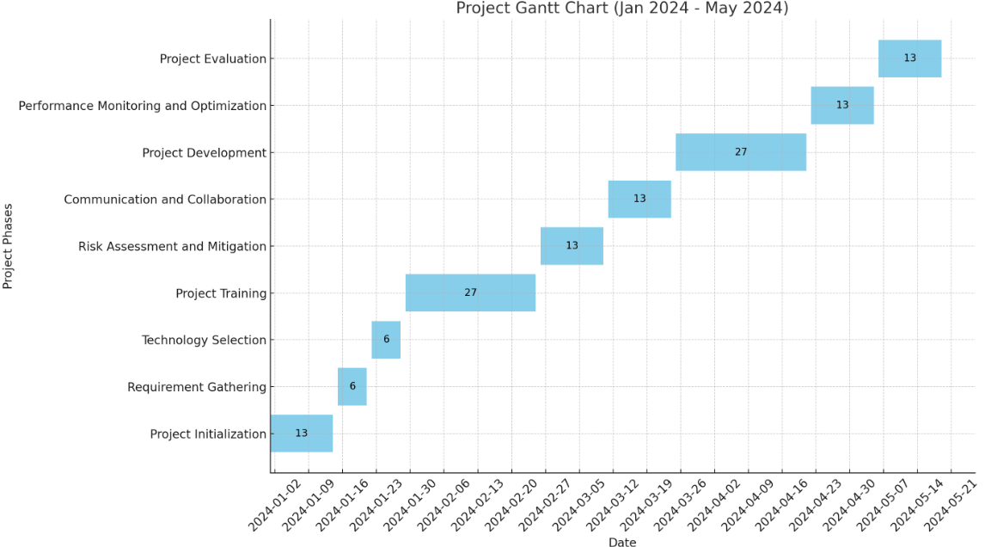

This chart provides a high-level overview of the project's timeline, with each task allocated a certain number of weeks for completion. Keep in mind that the durations and start dates may vary based on project-specific factors and resource availability. Additionally, tasks may overlap or have dependencies not fully represented in this simplified chart. Adjustments may be necessary based on further project planning and team discussions.

**Conclusion:**

By following the outlined timeline and steps for each phase of the project, the development of the Personalized Wellbeing Assistant can be managed effectively within a six-month timeframe. Proper planning, communication, collaboration, and evaluation processes are essential for ensuring the success of the project and delivering a transformative solution for improving health and wellness.

**CHAPTER 4**

**HARDWARE AND SOFTWARE REQUIREMENTS**

To build a project using the MERN stack for the frontend and .NET for the backend, you'll need a combination of hardware and software. Here's a breakdown of the requirements for each component:

**4.1 Hardware Requirements**

### Backend (.NET) Requirements:

1. **Server:**
   * CPU: Dual-core processor or higher
   * RAM: 8 GB or higher
   * Storage: 50 GB SSD or higher
2. **Database:**

MongoDB, a leading NoSQL database, offers a dynamic and scalable solution for managing data efficiently. With its document-oriented approach and flexible schema, MongoDB enables developers to store and query data in a highly adaptable manner. Its rich features, including indexing and replication, ensure high performance and reliability for modern applications.

### Frontend (MERN) Requirements:

1. **Client Machine:** Standard machine with modern web browser support.

**4.2 Software Requirements**

### Backend (.NET) Requirements:

1. **Development Environment:**
   * Visual Studio IDE for frontend development of the project in Html, Tailwind Css, Javascript, React.js.
   * Visual Studio Code for backend development of the project in Asp.Net MVC.
2. **NuGet Packages:** Entity Framework Core for database operations.

### Frontend (MERN) Requirements:

1. **Code Editor:** Visual Studio Code, Atom, Sublime Text, or any other preferred code editor.
2. **Node.js and NPM:** Same as backend requirements for the frontend development environment.
3. **React:** JavaScript library for building user interfaces.
4. **State Management:** Utilize React hooks for streamlined state management, particularly focusing on user profiles and preferences within the application, ensuring efficient data handling and updates across components.
5. **Styling:** Tailwind CSS for efficient styling.
6. **Axios:** A promise-based HTTP client for making API requests to the .NET backend.
7. Top of Form

### Additional Tools and Services

1. **Version Control:** Git and a GitHub or GitLab account for version control.
2. **API Documentation:** Swagger or Postman for documenting and testing APIs.
3. **Deployment:** Hosting services like Heroku, AWS, or Azure for deploying both frontend and backend.
4. **Security:**
   * SSL certificates for secure data transmission.
   * Security best practices for handling user data.

**CHAPTER 5**

**DESIGN OF THE PROJECT**

**1. Architectural Diagram**

The architectural diagram of the Personalized Wellbeing Assistant depicts the high-level structure of the system, including its components and their interactions. Here's a simplified representation:

Application Server

User Interface

Database

* **User Interface**: This component represents the interface through which users interact with the system. It includes web and mobile interfaces for inputting data, receiving recommendations, and visualizing progress.
* **Application Server**: This component serves as the backend of the system, handling data processing, recommendation generation, and communication with the database. It comprises modules for user authentication, data analysis, recommendation algorithms, and notification management.
* **Database**: This component stores user data, including profiles, inputted information, generated recommendations, and system configurations. It utilizes a relational database management system (RDBMS) to ensure data integrity and scalability.

**2. Entity-Relationship (ER) Diagram**

An Entity-Relationship (ER) diagram is a visual representation used to model the structure of a database. It illustrates the entities within the database, the attributes associated with each entity, and the relationships between entities. Entities are typically nouns, representing real-world objects or concepts, while attributes describe the properties of entities. Relationships show how entities are related to each other and are often expressed using verbs or phrases. ER diagrams are commonly used in database design to help developers and stakeholders understand the organization of data and the connections between different pieces of information within a database schema.Top of Form

The ER diagram illustrates the relationships between various entities in the system and their attributes. Explanation of Entities:

1. **User**: Stores information about users of the system including their UserID, Username, Password, Age, Weight, Fitness Goals, and Dietary Preferences, Height etc..
2. **Meal**: Stores information about meals recorded by users including Food Item Id, UserID (foreign key referencing User), Timestamp, Food Item, Quantity, and Calories etc. This also includes the information about water consumption by users.
3. **Exercise**: Stores information about exercises recorded by users including ExerciseID, UserID (foreign key referencing User), Timestamp, Exercise Type, Duration, and Calories.
4. **Record**: Stores information about system notifications sent to users including RecordId, UserID (foreign key referencing User), Timestamp, Calories, Fat, Proteins and other details, and Record Type(Food or Water) etc.

Relationships:

* Each User can have multiple Meals and Exercises (one-to-many relationship).
* Each Meal and Exercise is associated with one User (many-to-one relationship).
* Each User can receive multiple Records (one-to-many relationship).
* Each Record is associated with one User (many-to-one relationship).

This ER diagram provides a visual representation of the entities, attributes, and relationships within the Personalized Wellbeing Assistant project, aiding in understanding the data structure and connections between different components of the system.

Here's a simplified ER diagram for the Personalized Wellbeing Assistant:

e (Meal

Tutor

Admin

User

Student

Reviews

Intake Reminder,

**3. Data Flow Diagram (DFD)**

The DFD illustrates the flow of data within the Personalized Wellbeing Assistant system. A Data Flow Diagram (DFD) is a visual representation showing how data moves within a system and between external entities. It uses standardized symbols to depict processes, data flows, data stores, and external entities, providing a concise overview of the system's structure and operation. DFDs are hierarchical, allowing for decomposition into multiple levels of detail, aiding in system understanding and communication during software engineering and systems analysis.

Here's a simplified DFD showing the main processes and data flows:

***Zero level DFD:***

TutorFinder

User Interface

Database

***First level DFD:***

TutorFinder

User

Student

Tutor

Studentmanagement

TutorManagement

ReviewManagement

***Second level DFD:”***

TutorFinder

User

Tutor

Student

TutorManagement

StudentManagement

Search Tutor

registerTutor

Update Availability

Search time slots

Search Tutor

Update Availability

**4. Flowchart of Project Structure**

The flowchart illustrates the sequence of steps involved in the functioning of the Personalized Wellbeing Assistant. Here's a simplified flowchart:

User Authentication

Input data (User Interface)

Start

Start --> User Authentication

Process data

(Application Server)

Output Recommendations (user interface)

Generate Recommendations (Application Server)

End

--> Input Data --> Process Data --> Generate Recommendations --> Output Recommendations --> End

Each step in the flowchart represents a stage in the functioning of the system. Here's a brief explanation of each step:

1. **Start:** The starting point of the flowchart.
2. **User Authentication:** Users authenticate themselves to access the system securely.
3. **Input Data (User Interface):** Users input data such as daily meals, exercise routines, and lifestyle habits through the user interface.
4. **Process Data (Application Server):** The application server processes the inputted data, analyzing it to generate personalized recommendations for nutrition, fitness, and lifestyle improvements.
5. **Generate Recommendations (Application Server):** Based on processed data and user profiles, the application server generates personalized recommendations for nutrition, fitness, and lifestyle improvements.
6. **Output Recommendations (User Interface):** Generated recommendations are displayed to users through the user interface for their review and action.
7. **End:** The endpoint of the flowchart.

This flowchart provides a visual representation of the sequential steps involved in the functioning of the Personalized Wellbeing Assistant project, illustrating the flow of data and interactions between the user interface and the application server.

**5. Structure of Database Tables**

Here's a description of the structure of database tables for the Personalized Wellbeing Assistant:

* **User**: Stores user information including UserID, Username, Password, Age, Weight, Fitness Goals, Height, and Dietary Preferences.
* **Meal**: Stores information about meals recorded by users including Food Item Id, UserID (foreign key referencing User), Timestamp, Food Item, Quantity, and Calories etc. This also includes the information about water consumption by users.
* **Exercise**: Stores information about user exercises including ExerciseID, UserID, Timestamp, Exercise Type, Duration, and Calories Burned.
* **Record**: Stores information about system notifications sent to users including RecordId, UserID (foreign key referencing User), Timestamp, Calories, Fat, Proteins and other details, and Record Type(Food or Water) etc.
* **Rules of Sample Data Values:**
* **UserID:** Unique identifier for each user (e.g., 1, 2, 3).
* **Username:** Unique username for each user (e.g., user1, user2, user3).
* **Password:** Encrypted password for user authentication.
* **Age:** Age of the user in years (e.g., 30, 35, 40).
* **Weight:** Weight of the user in kilograms (e.g., 70, 75, 80).
* **Height:** Height of the user in cm (e.g., 170, 145, 180).
* **Fitness Goals:** User's fitness goals such as weight loss, muscle gain, or maintenance.
* **Dietary Preferences:** User's dietary preferences such as vegetarian, vegan, or omnivore.
* **MealID:** Unique identifier for each meal entry.
* **Timestamp:** Date and time of the meal or exercise entry.
* **Food Item:** Name of the food item consumed during the meal.
* **Quantity:** Quantity of the food item consumed.
* **Calories:** Calories associated with the food item.
* **Fats:** Fats associated with the food item.
* **Carbs:** Carbs associated with the food item.
* **Protein:** Protein associated with the food item.
* **ExerciseID:** Unique identifier for each exercise entry.
* **Exercise Type:** Type of exercise performed (e.g., jogging, swimming, weightlifting).
* **Duration:** Duration of the exercise session in minutes.
* **Calories Burned:** Calories burned during the exercise session.
* **RecordID:** Unique identifier for each system record.
* **Record Type:** Type of record (e.g., meal reminder, water intake reminder, workout reminder).

**Conclusion:**

The detailed design of the Personalized Wellbeing Assistant encompasses architectural diagrams, entity-relationship diagrams, data flow diagrams, flowcharts, and database structures. These design artifacts provide a clear understanding of the system's structure, functionality, and data flow, laying the groundwork for its successful implementation.

**CHAPTER 6**

**IMPLEMENTATION OF THE PROJECT**

**Introduction:** My project "**WELLBEING: PERSONAL ASSISTANT**" is designed to simplify the process of tracking daily calorie intake for individuals striving to maintain a balanced diet and healthy lifestyle. By leveraging user input, our assistant provides a convenient platform for users to log their daily food consumption and monitor their calorie intake over time.

**Key Features**

1. **Input Tracking:** Users can easily input their daily meals and snacks into the system, specifying portion sizes and food details.
2. **Calorie Calculation:** The assistant automatically calculates the total calorie intake based on the input provided by the user, considering the nutritional content of each food item.
3. **Calorie Record:** A comprehensive log is maintained, displaying the total calorie intake for each day and allowing users to review their dietary habits over time.
4. **Visualization:** Users can visualize their calorie intake data through simple graphs or charts, facilitating easy interpretation and tracking of their progress towards dietary goals.

**Benefits**

* **Simplified Tracking:** With our assistant, users no longer need to manually calculate their calorie intake or keep track of complex spreadsheets. Everything is conveniently managed within the application.
* **Awareness and Accountability:** By maintaining a calorie log, users gain valuable insights into their dietary habits, fostering awareness and accountability for their food choices.
* **Goal Setting:** Armed with a clear understanding of their calorie intake, users can set realistic dietary goals and make informed decisions to achieve them.

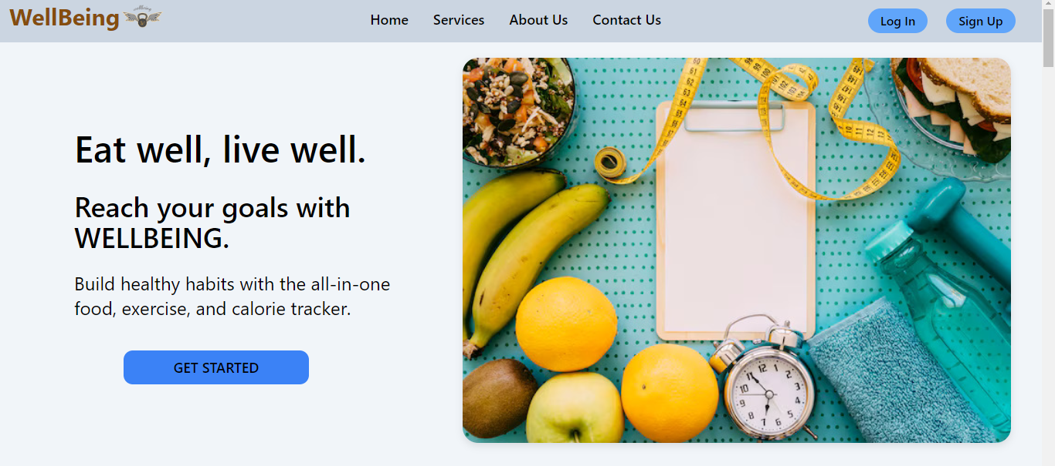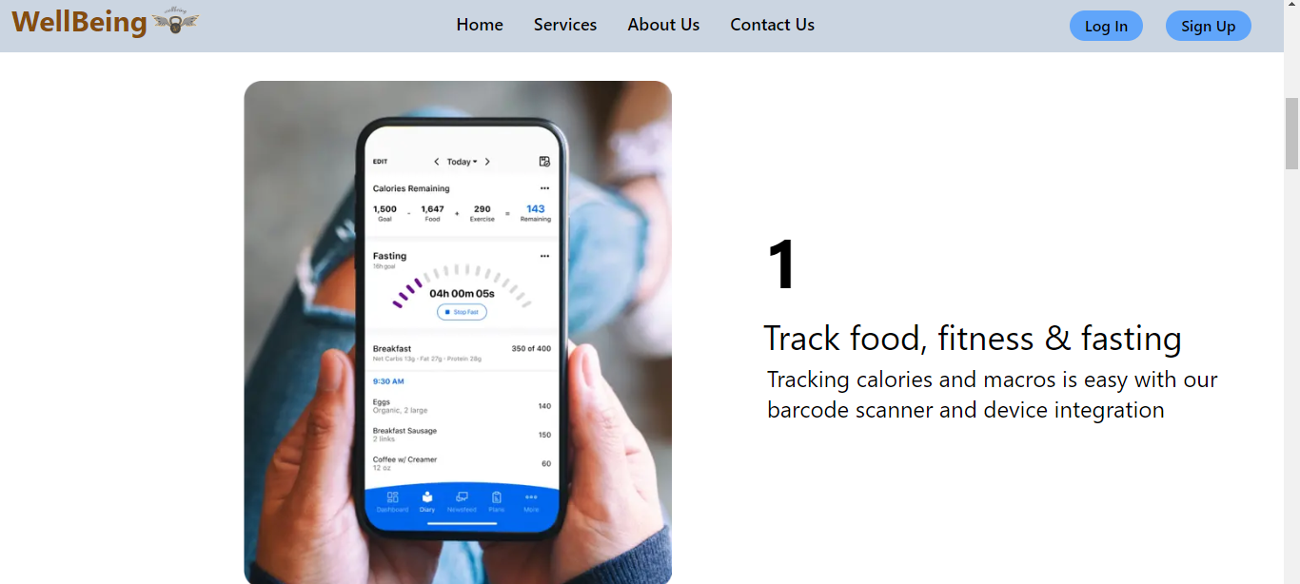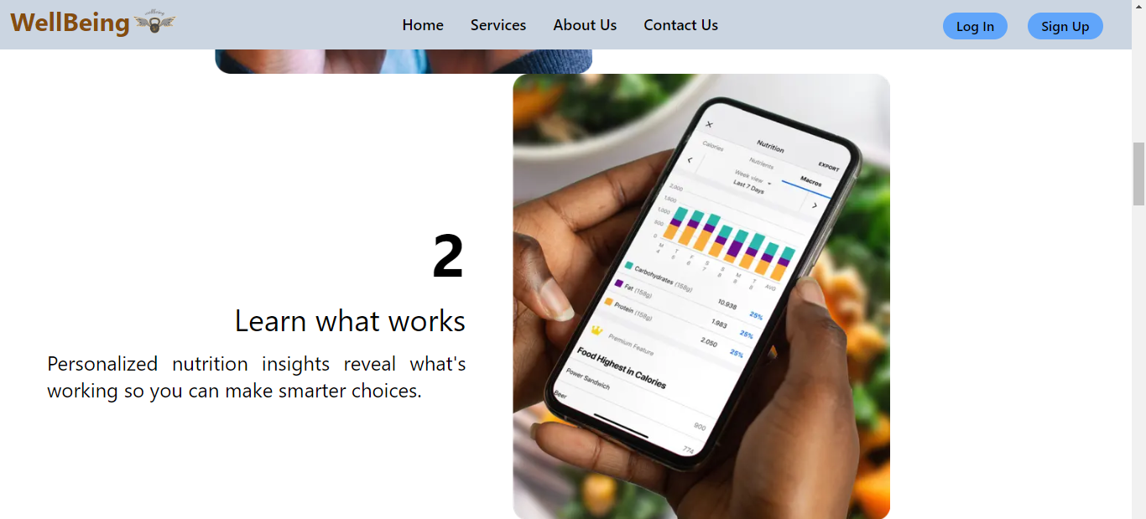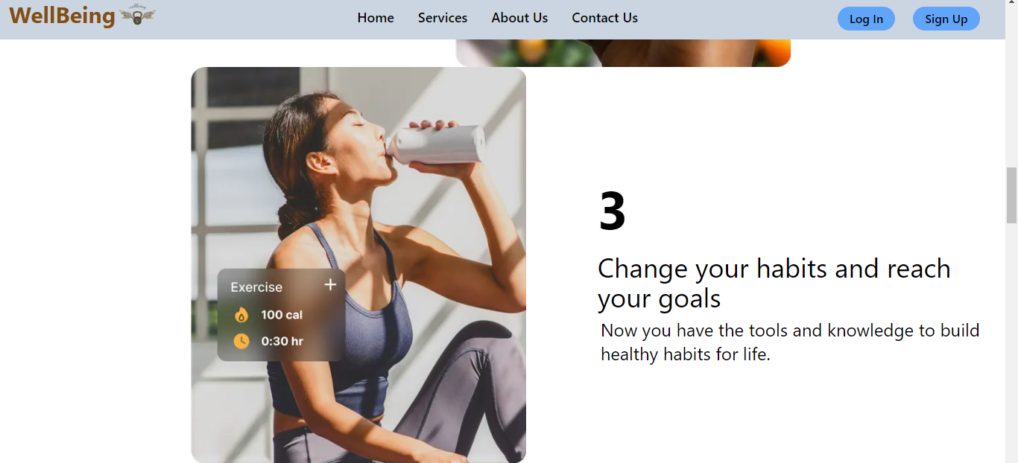

**Development Process:** The frontend of the project was developed using React, a popular JavaScript library for building user interfaces, and styled with Tailwind CSS for efficient and customizable styling. Meanwhile, the backend was built using ASP.NET, providing robust server-side functionality and API endpoints for seamless communication with the frontend. This technology stack ensured a modern and responsive user experience on the frontend, coupled with a reliable and scalable backend infrastructure to support the application's core functionalities.

Here are the code snippets of the landing page of the project: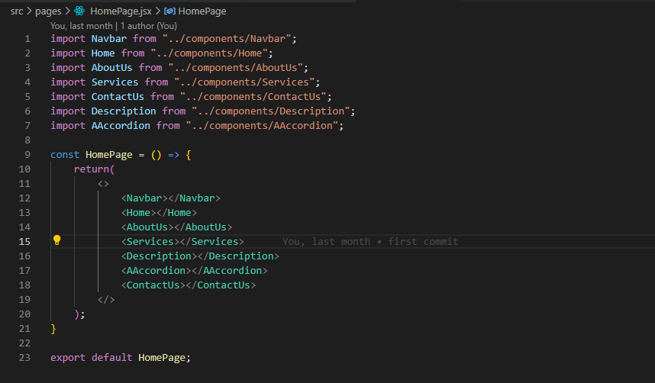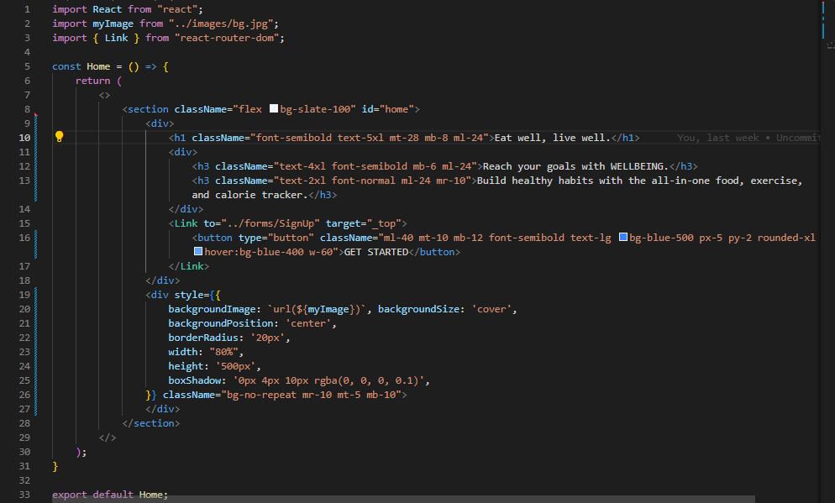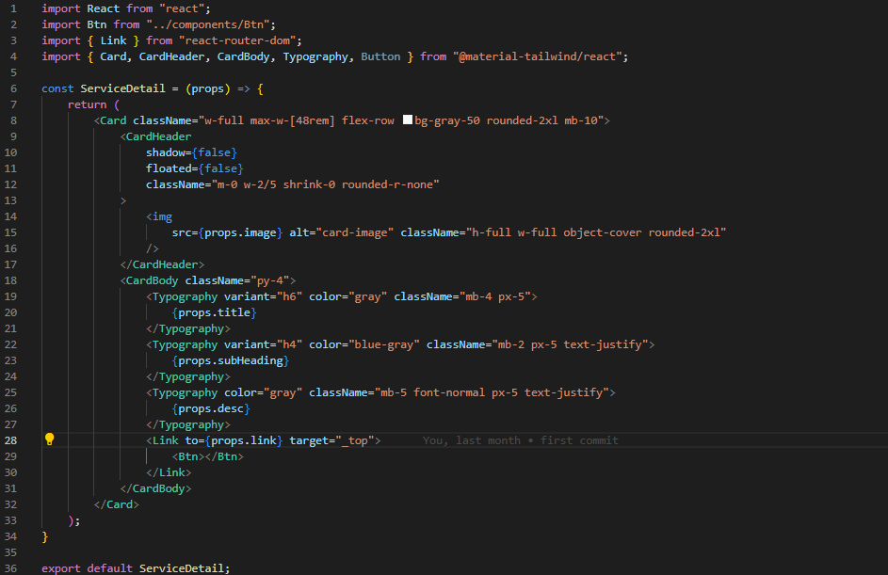

**Key Features and Functionality**

1. **User Authentication:** Users can securely sign up for an account or log in with their credentials, ensuring personalized access to their data and features.

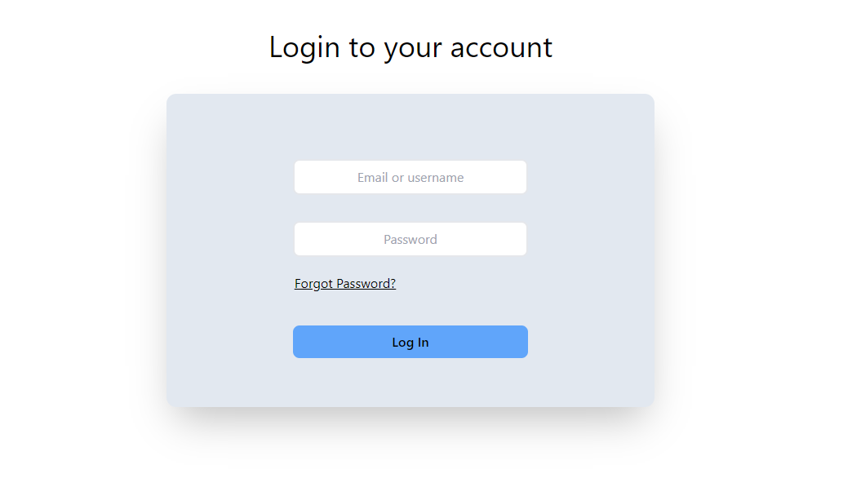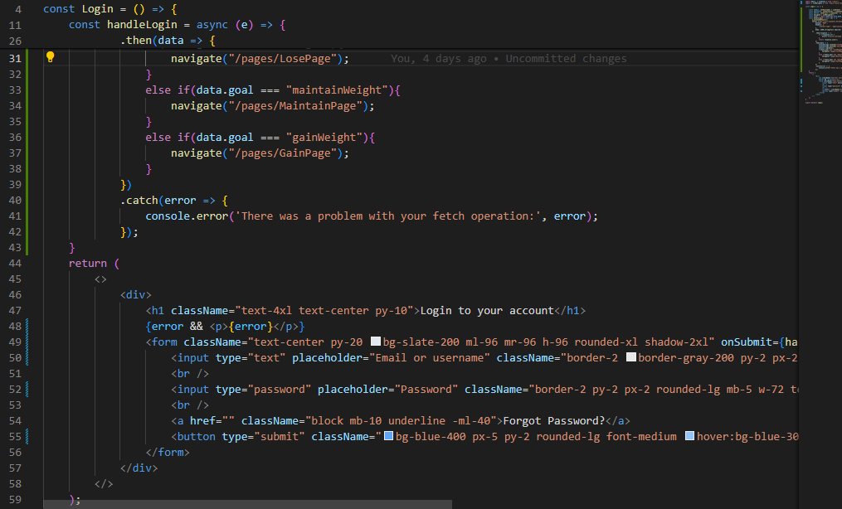 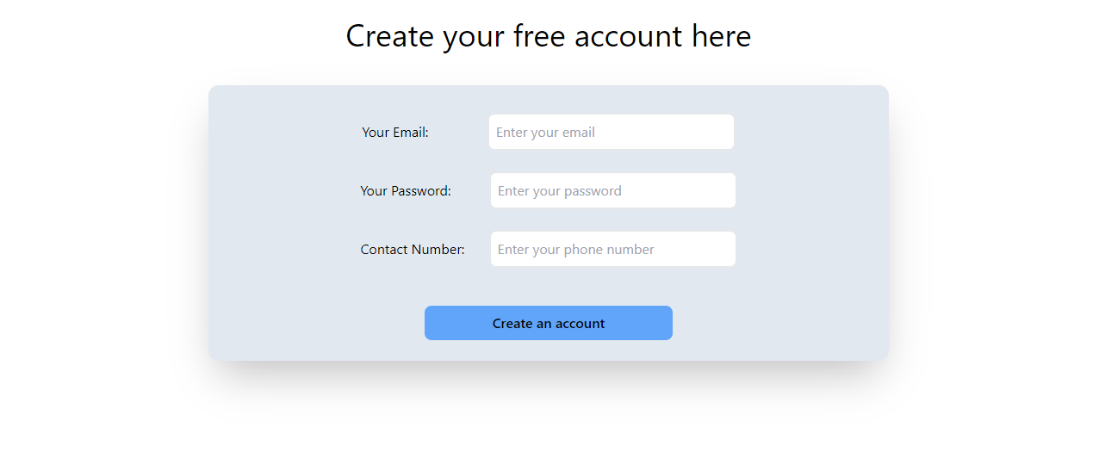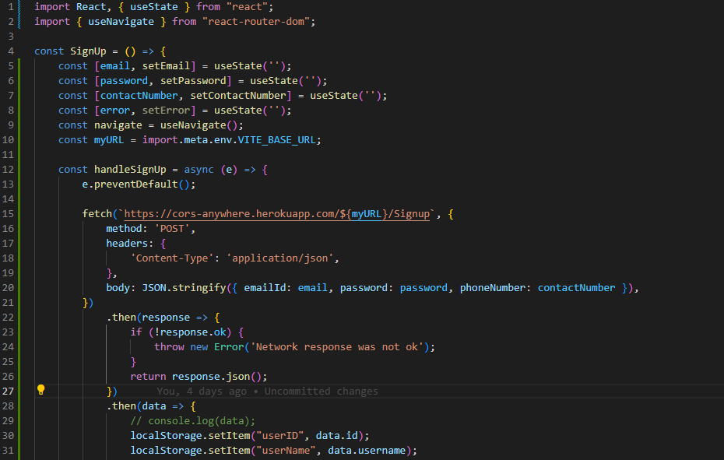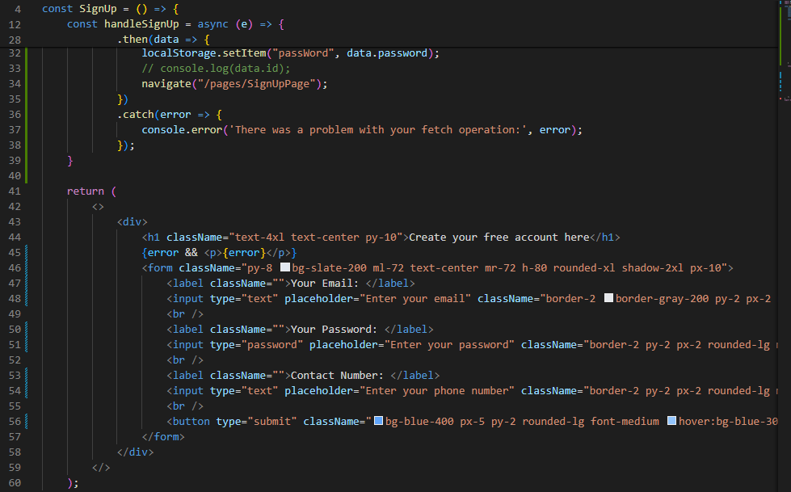

1. **Food Item Logging:** Users can add their daily food items consumed, specifying details such as portion sizes and meal times. The system calculates the calorie consumption based on the nutritional content of each food item added.
2. **Calorie Consumption Tracking:** A comprehensive log is maintained, showcasing the total calorie intake for each day. Users can track their daily calorie consumption trends over time, helping them make informed dietary decisions.
3. **Ideal Weight Calculation:** Based on user-provided information such as age, height, weight, and activity level, the system calculates an ideal weight goal. Users can track their progress towards their ideal weight goal, motivating them to maintain a healthy lifestyle.
4. **Record Maintenance:** The system maintains a detailed record of users' food intake, calorie consumption, and progress towards their ideal weight. Users can review and analyze their historical data to gain insights into their dietary habits and track their wellness journey.

These features empower users to take control of their nutrition and fitness goals by providing them with personalized guidance, real-time tracking, and actionable insights for maintaining a healthy lifestyle.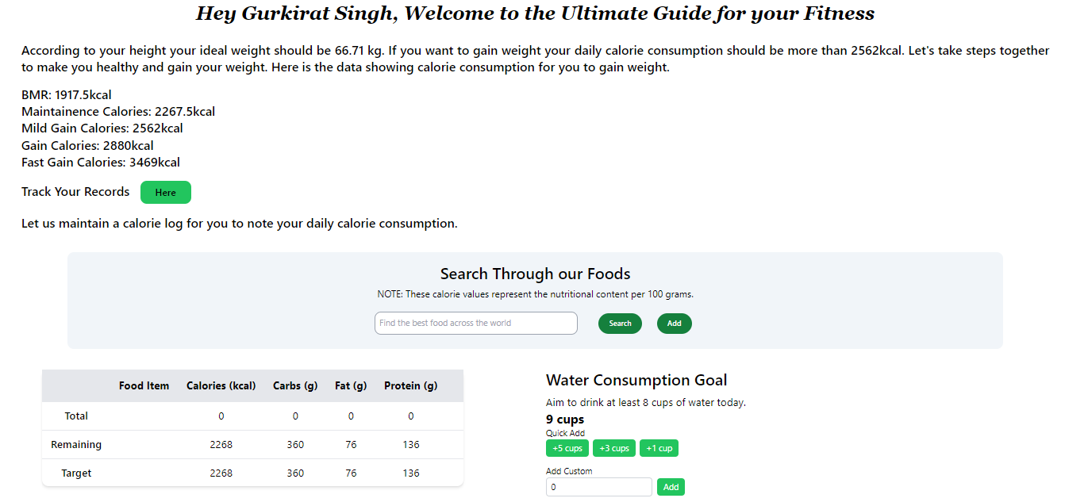 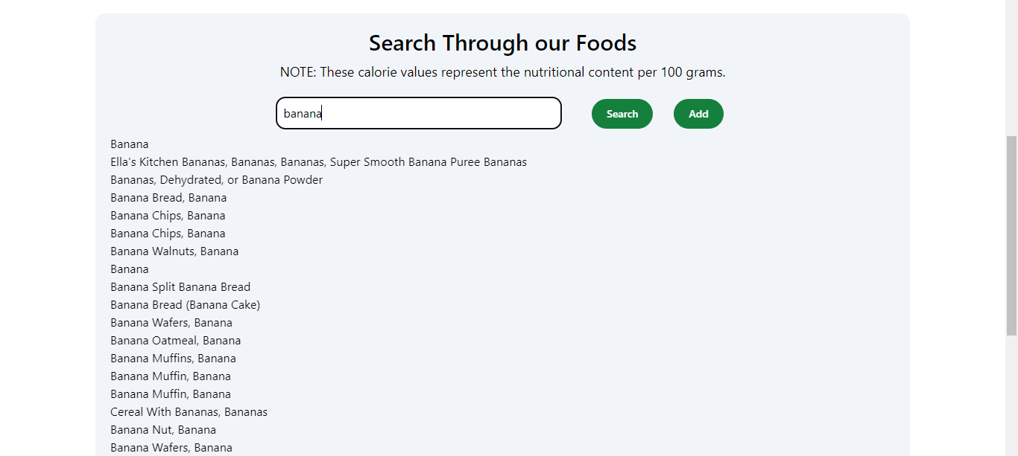

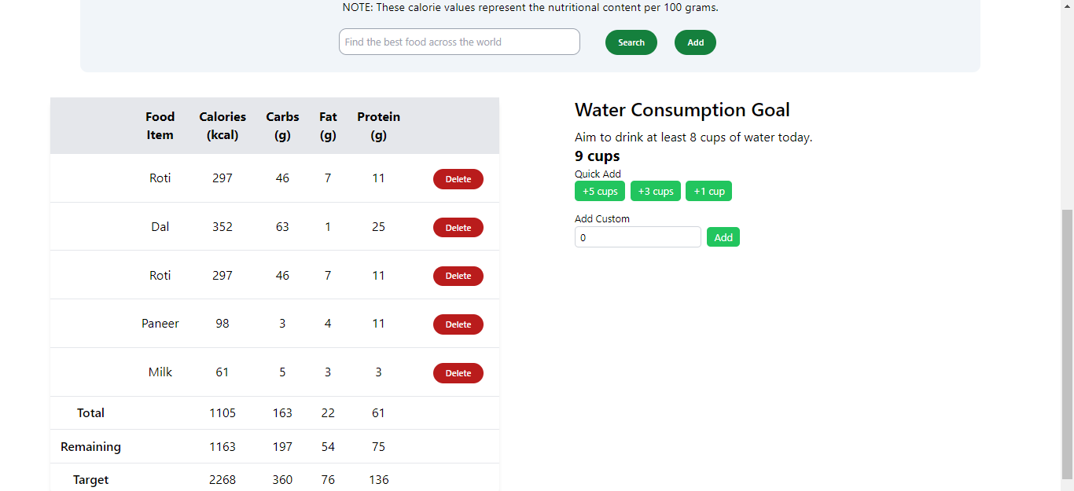

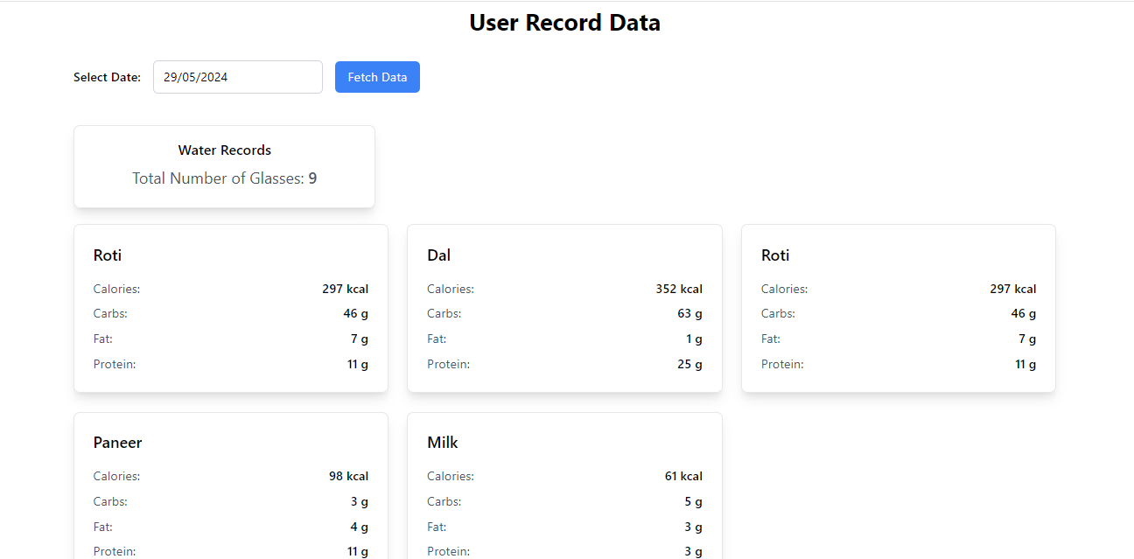

**User Interface Design:**

1. **Features Carousel:** The features section prominently showcases a carousel displaying various elements such as yoga asanas, height-weight charts, diet recommendations, and workout plans. Each slide in the carousel provides a brief overview of the feature, enticing users to explore further.
2. **Yoga Asana:** Within the carousel, users can view a selection of yoga asanas, each accompanied by a brief description and perhaps an illustrative image. Users can click or swipe through the carousel to discover different yoga poses and learn about their benefits.
3. **Height-Weight Chart:** Another slide in the carousel presents a height-weight chart, allowing users to visualize their ideal weight range based on their height. This chart serves as a reference for users to set realistic weight goals and track their progress over time.
4. **Diet Recommendations:** The carousel also includes slides showcasing diet recommendations and nutritional guidance, such as suggested meal plans, calorie intake targets, and tips for healthy eating habits. Users can access these recommendations for personalized guidance on maintaining a balanced diet and achieving their wellness goals.
5. **Workout Plans:** Finally, users can explore various workout plans tailored to their fitness levels and goals. The carousel highlights different types of workouts, including cardio, strength training, and flexibility exercises, along with suggested routines and exercise tips.

**User Experience:**

* The carousel design offers a visually engaging and interactive experience, allowing users to easily navigate through different features and content.
* By presenting a diverse range of wellness-related information in a concise and visually appealing format, the UI encourages users to explore and engage with the platform's offerings.
* Clear navigation controls, such as arrows or dots, enable users to browse through the carousel at their own pace, enhancing usability and accessibility.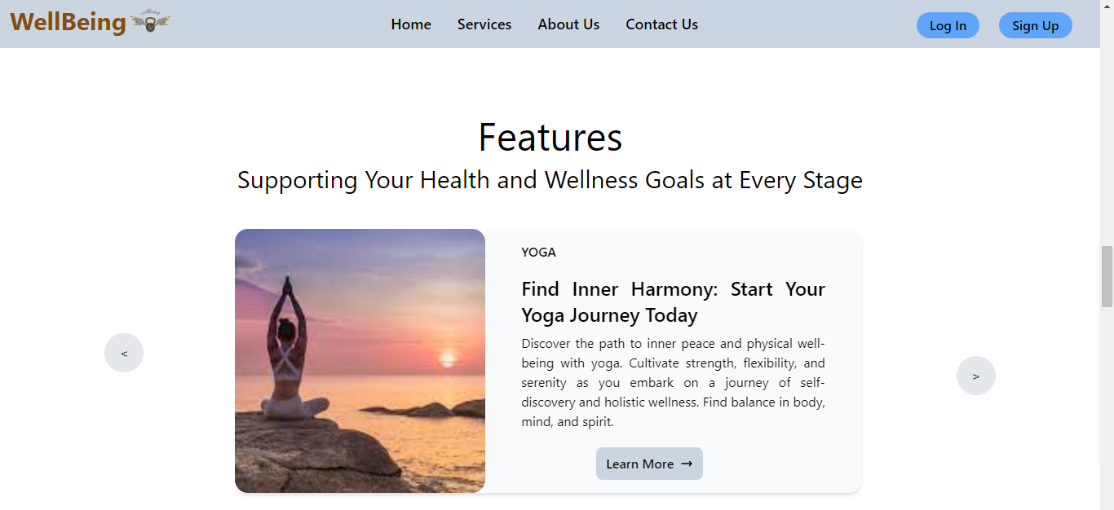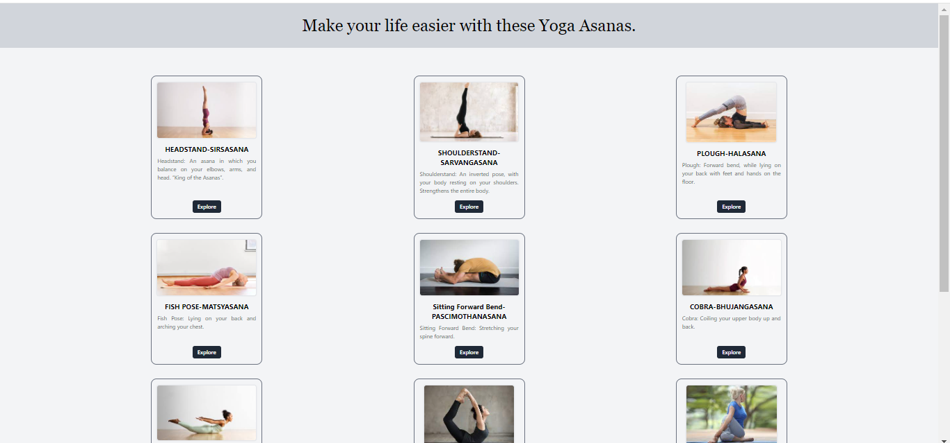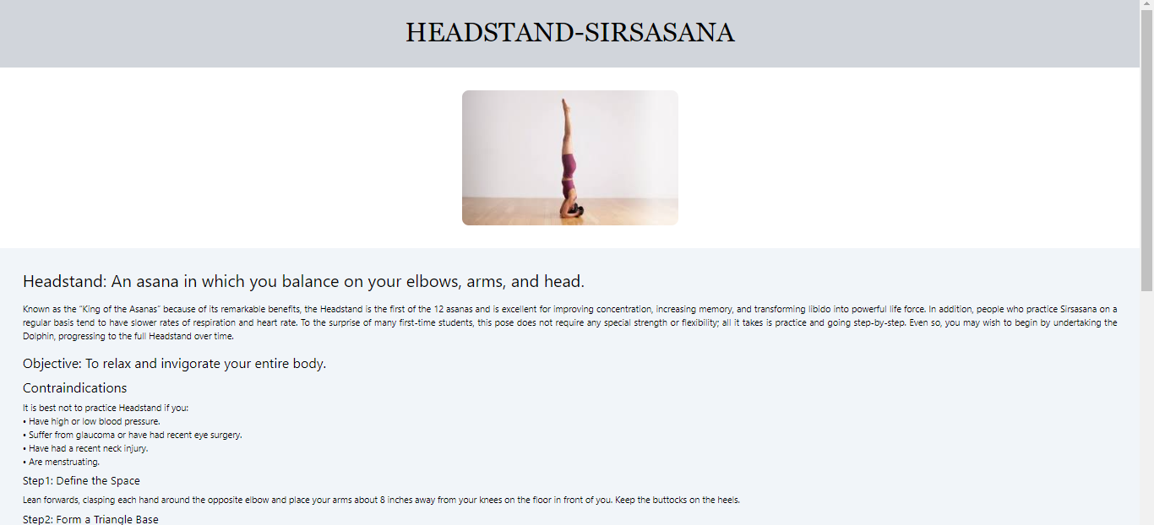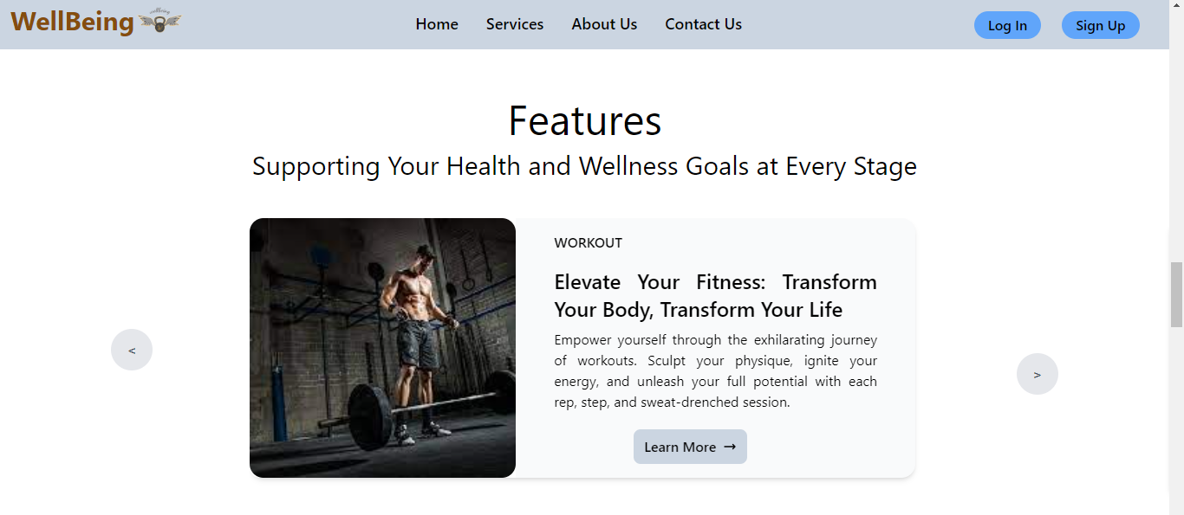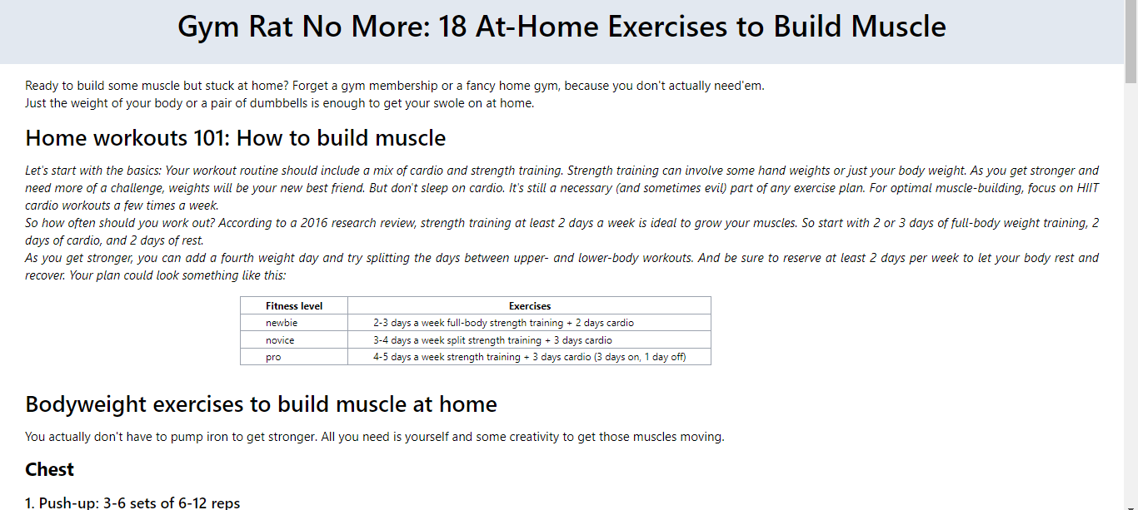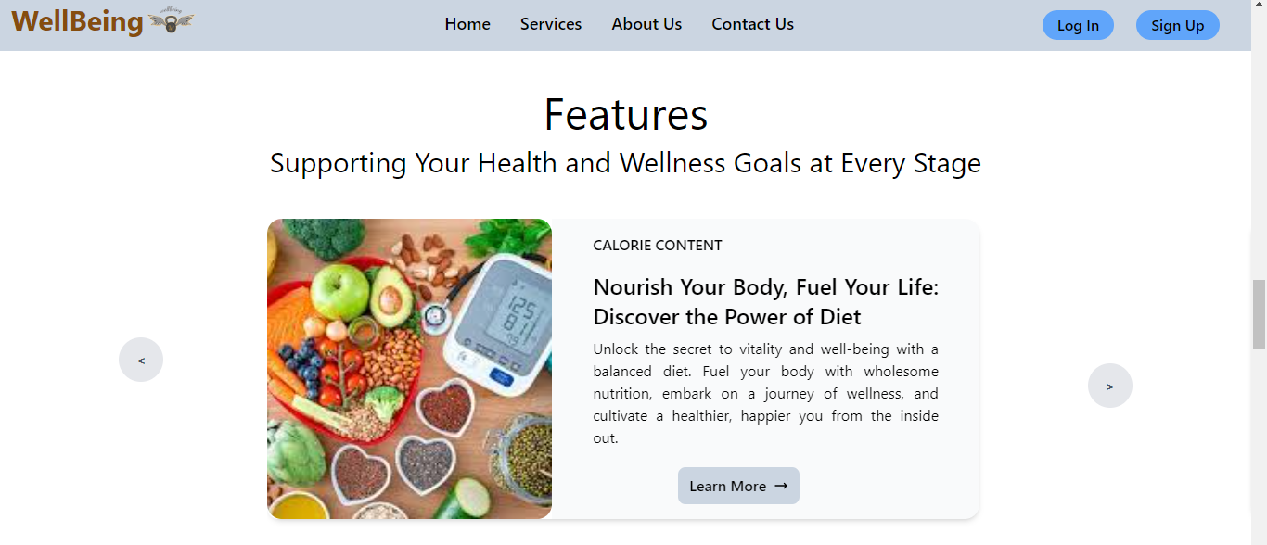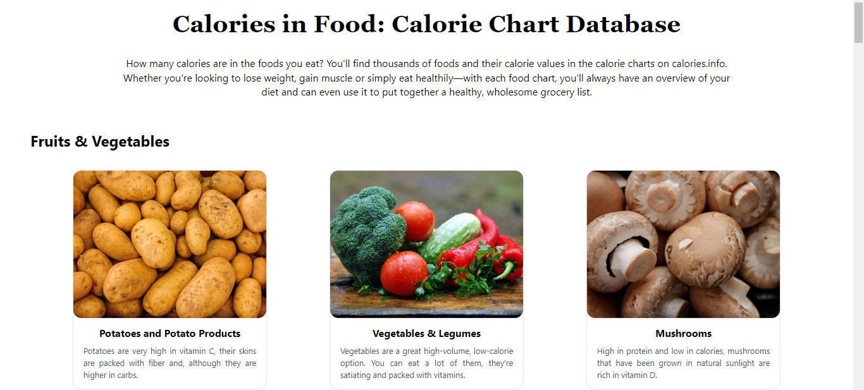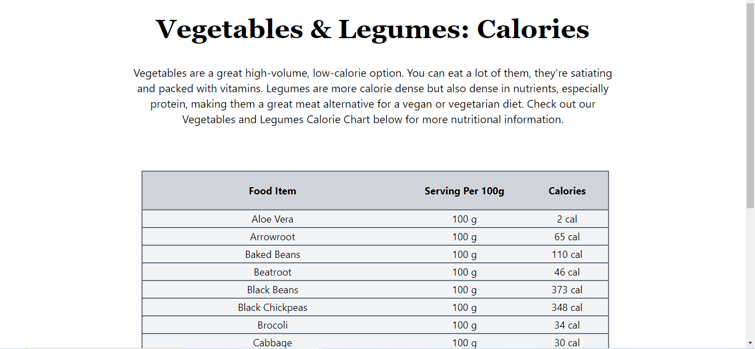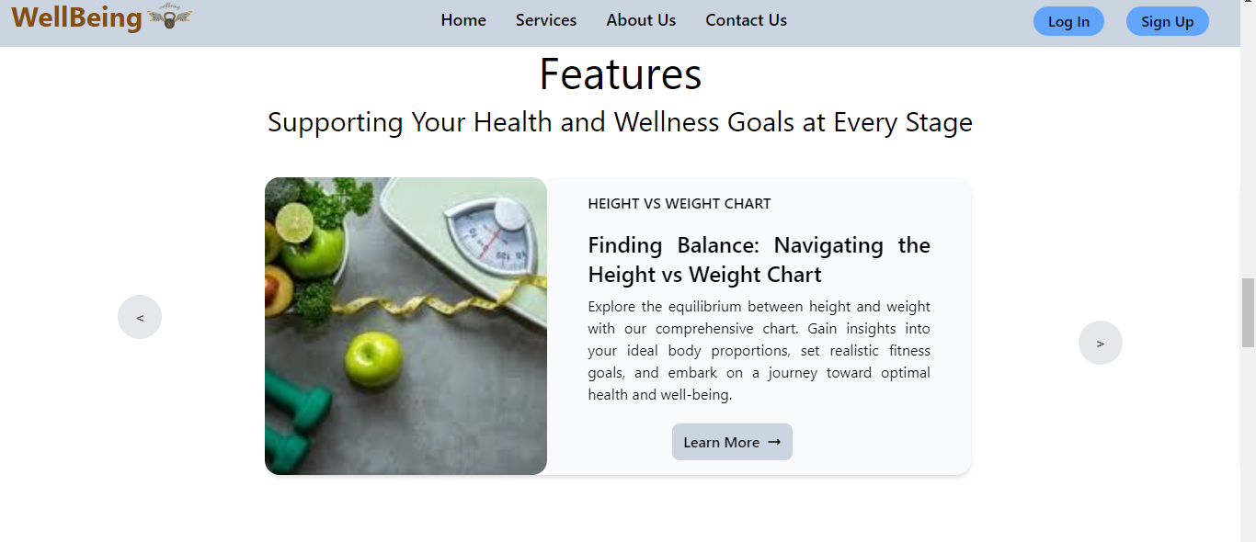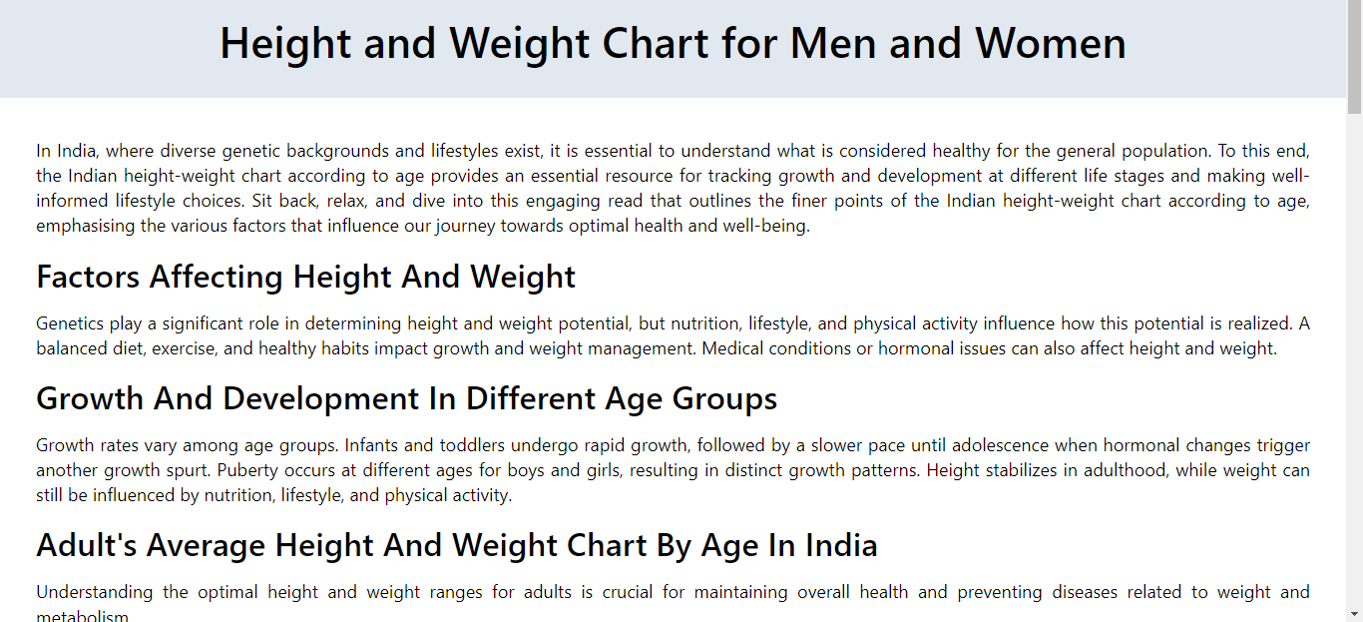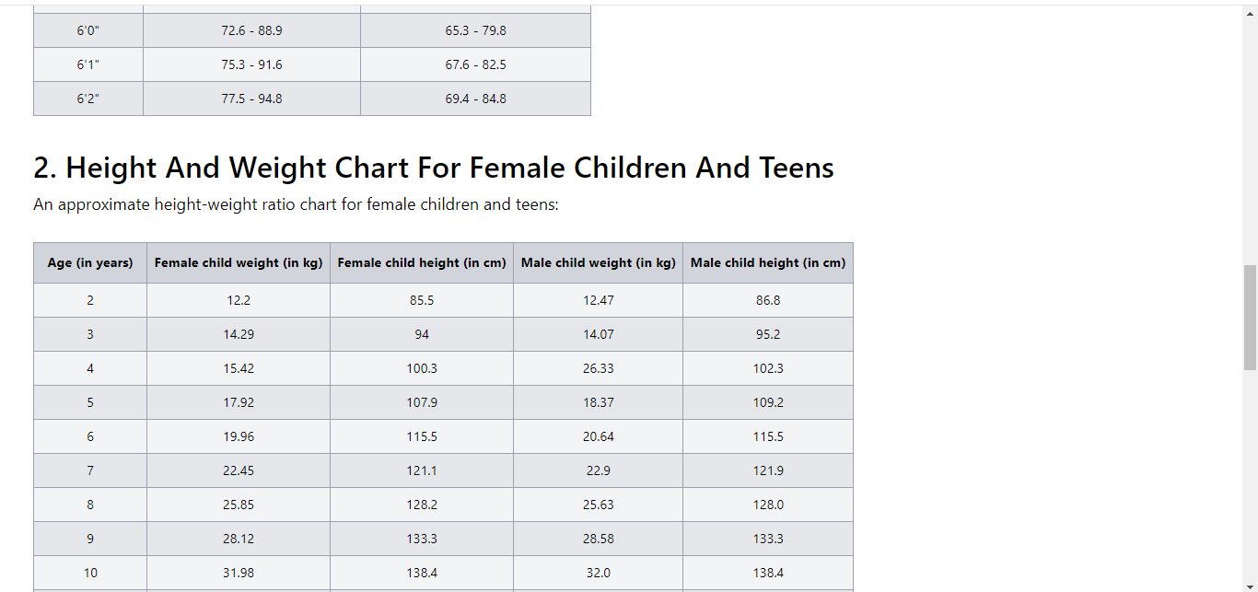

**Frontend Development:** This project harnesses the power of React.js for its frontend development, employing state-of-the-art features such as the useState hook API to ensure a highly responsive and interactive user interface. Leveraging React's component-based architecture, the UI is efficiently broken down into reusable components, facilitating streamlined development and bolstering code maintainability. State management within the application is seamlessly handled through React's built-in state and props mechanisms, further enhanced by the useState hook API, enabling dynamic management of data and UI states with simplicity and efficiency. Moreover, client-side routing is achieved using libraries such as React Router, enabling effortless navigation between different views and pages within the application. This strategic utilization of React.js, along with advanced state management techniques, empowers the project with a robust frontend infrastructure, ensuring a smooth and intuitive user experience for all.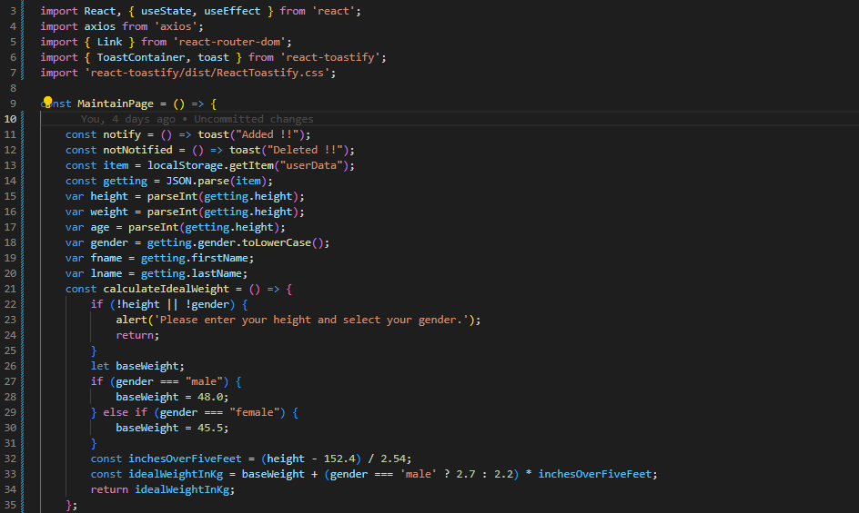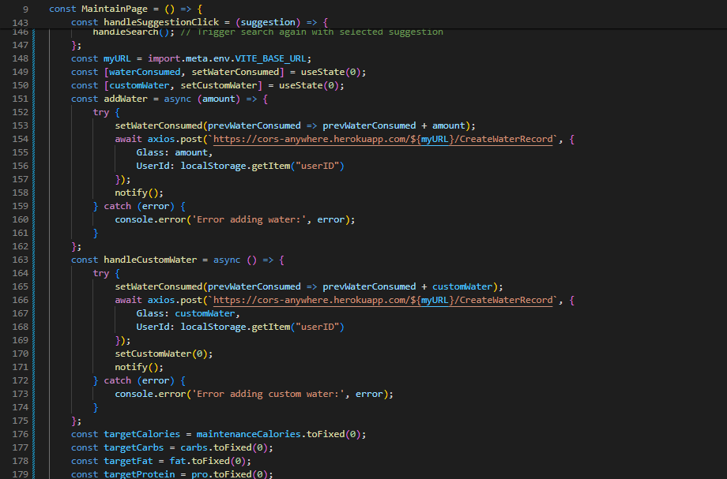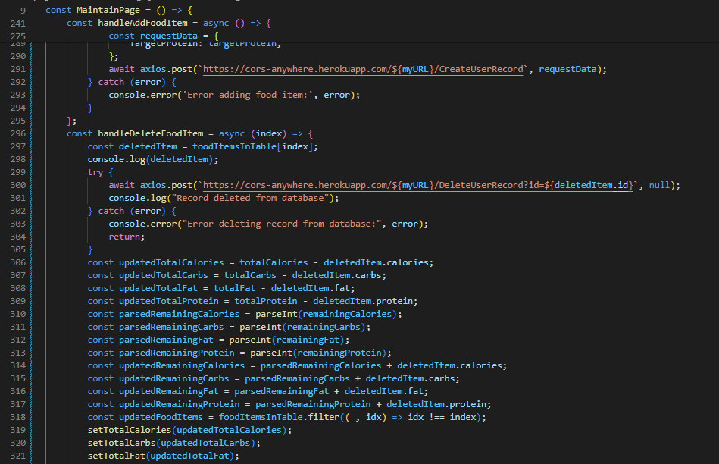

**Backend Development:** The backend development process for this project was orchestrated using ASP.NET, a robust framework recognized for its ability to build scalable and secure web applications. Leveraging ASP.NET, server-side logic was meticulously crafted to handle incoming requests, process user actions, and generate dynamic responses. Through seamless integration with databases, facilitated by Entity Framework, efficient management of data storage and retrieval was achieved. Additionally, ASP.NET's capabilities were harnessed to develop RESTful APIs, enabling seamless communication between the frontend and backend systems while ensuring robust user authentication and authorization mechanisms.

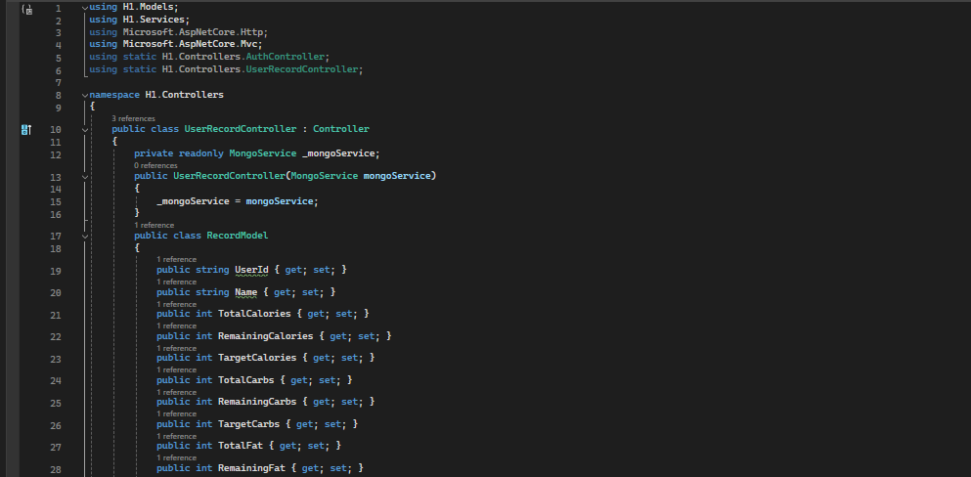

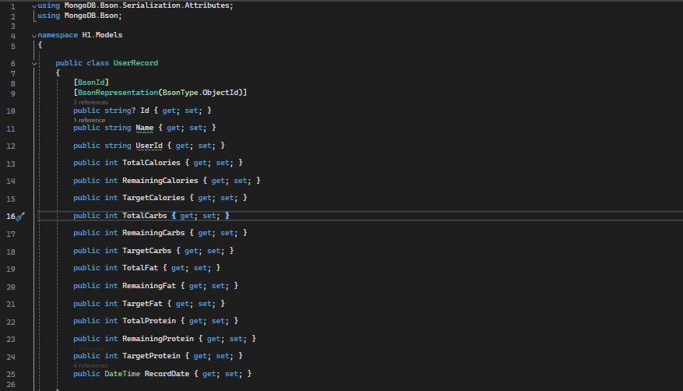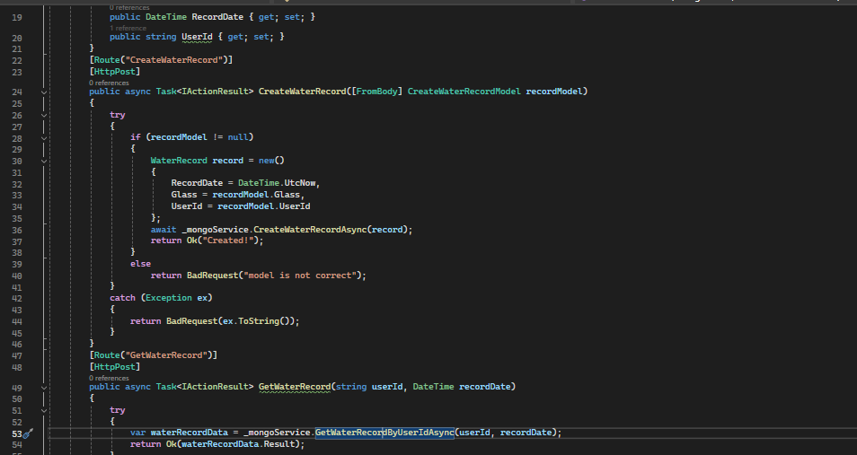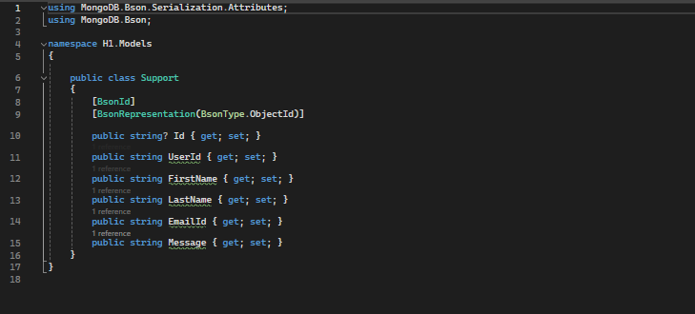

**Testing and Quality Assurance:** Testing for the reliability and performance of the Personalized Wellbeing Assistant was meticulously conducted using a combination of testing methodologies. Swagger and Postman were instrumental in facilitating this process, providing comprehensive tools for API testing and documentation, ensuring the application met stringent quality standards before deployment.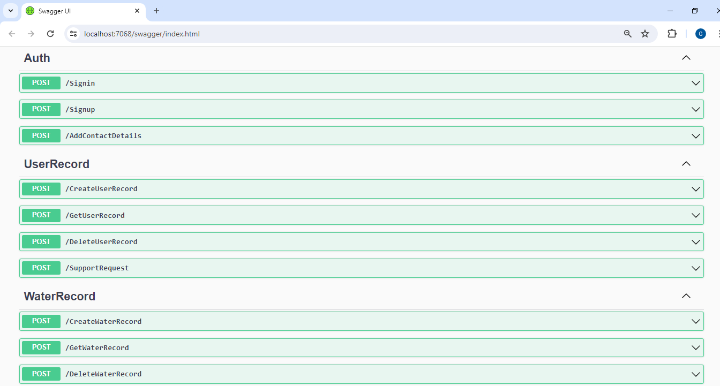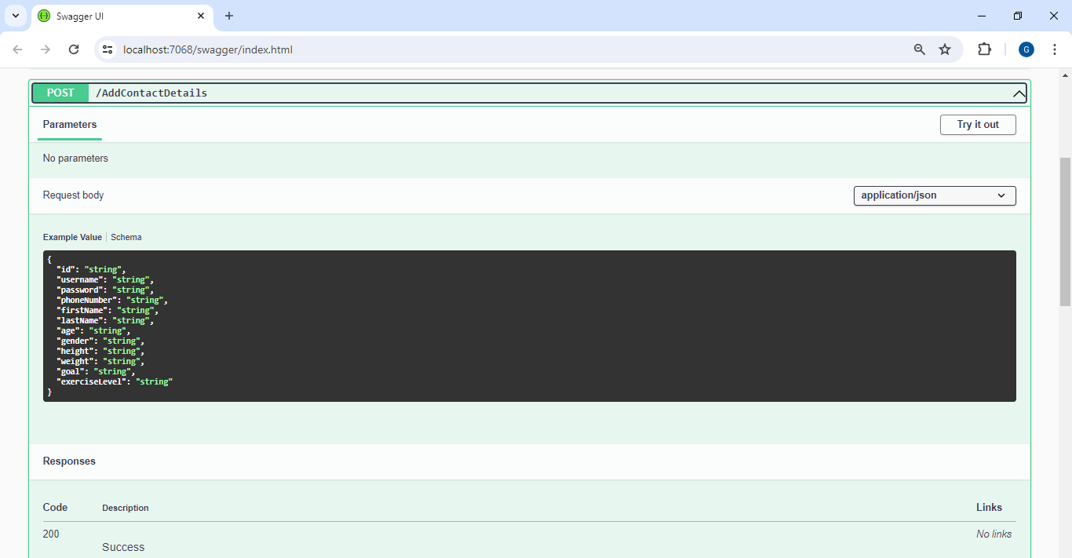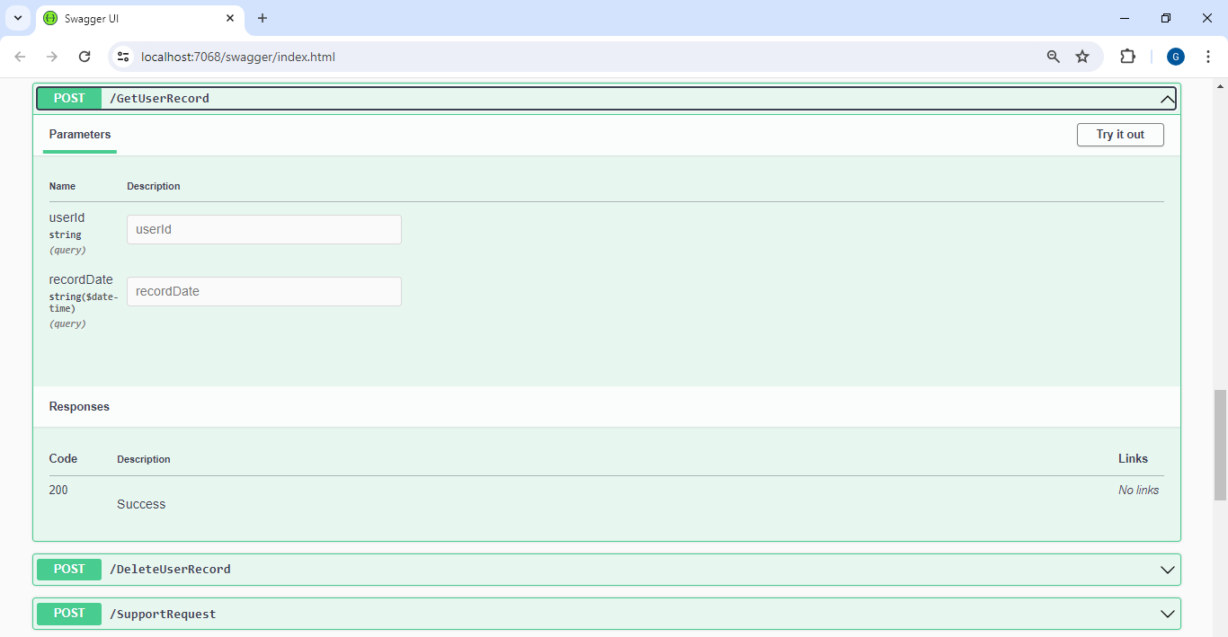

Top of Form

### Successful Deployment and User Engagement:

Following the comprehensive Testing and Quality Assurance phase, where the Personalized Wellbeing Assistant was meticulously evaluated for reliability and performance using Swagger and Postman, we successfully deployed the application. Since the deployment, user engagement has been promising. Users have actively interacted with the Personalized Wellbeing Assistant, and their inputs have been systematically recorded in our database. Below, we present a selection of user entries that highlight the application's functionality and its positive reception.

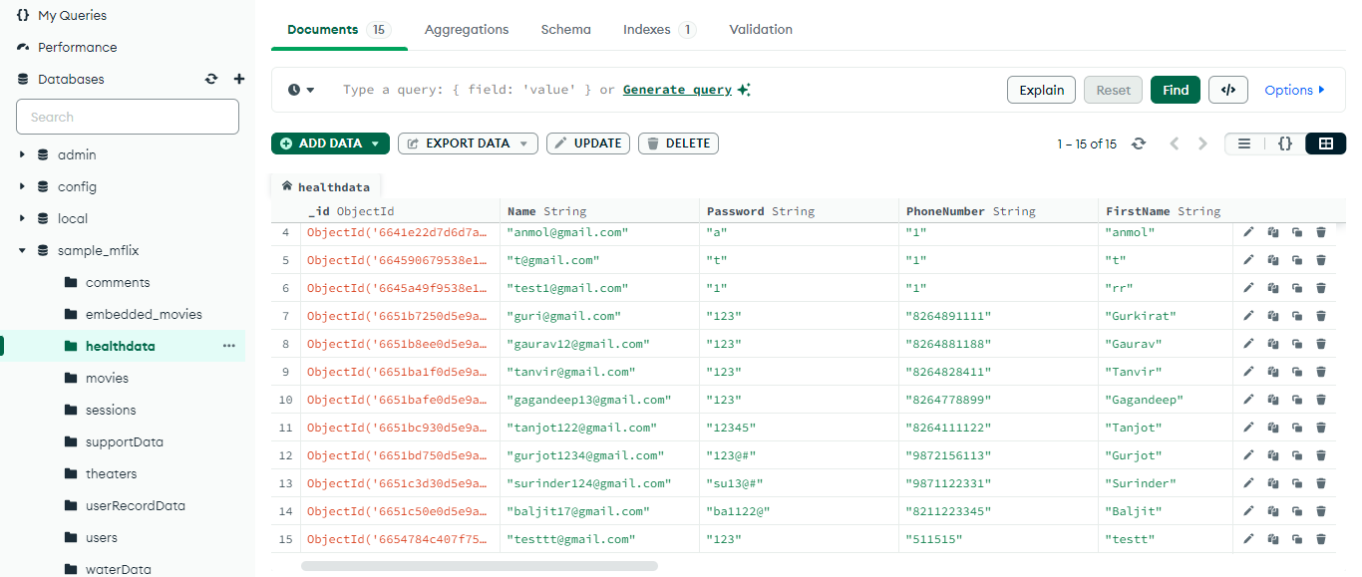

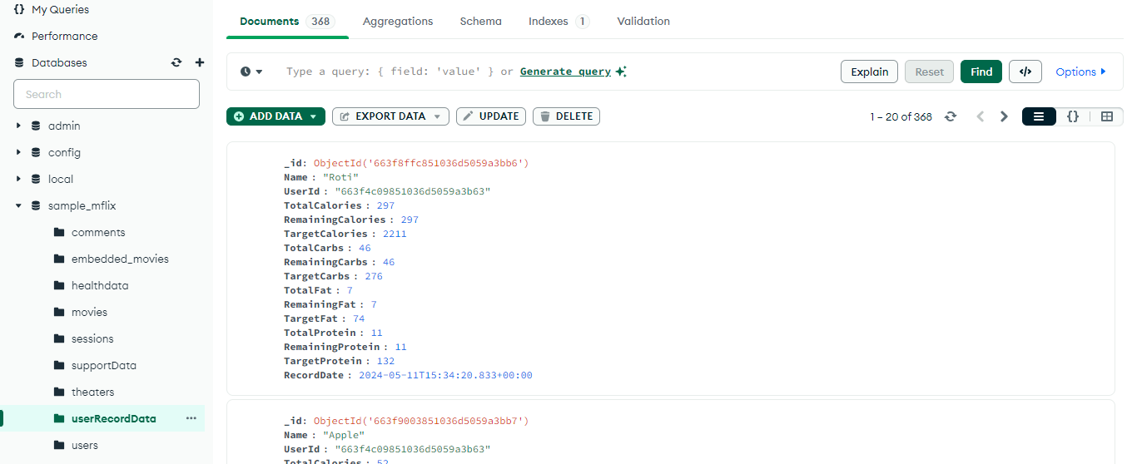

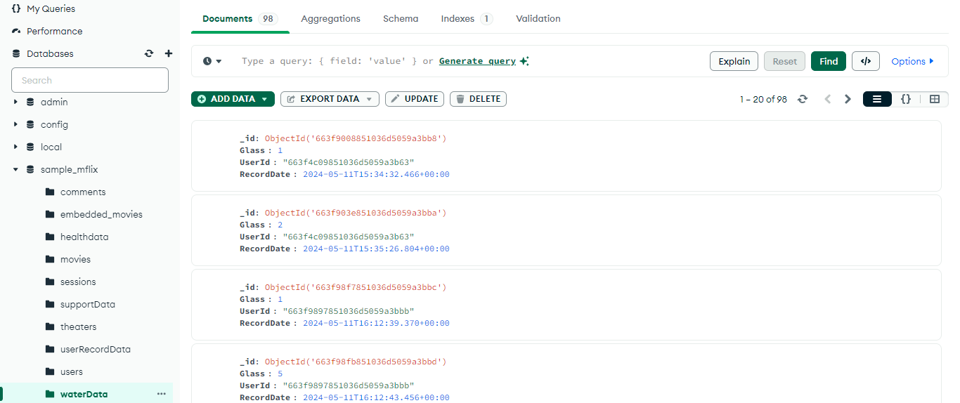

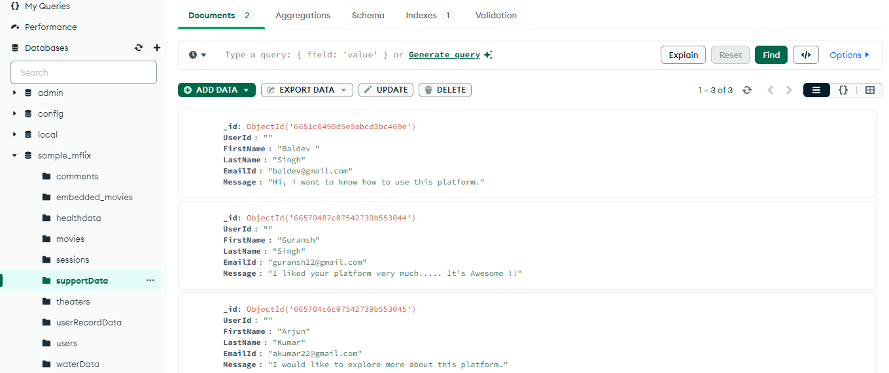

In conclusion, the successful implementation of the Personalized Wellbeing Assistant not only signifies a significant milestone in digital health innovation but also underscores our commitment to empowering individuals with personalized, technology-driven solutions for achieving holistic wellbeing in today's fast-paced world.

**CHAPTER 7**

**CONCLUSION AND FUTURE SCOPE**

**Conclusion**

In an era marked by the relentless pace of modern life, the Personalized Wellbeing Assistant emerges as a beacon of hope, offering a transformative solution to the pressing challenges of maintaining optimal health and wellness. Through its innovative approach, this project endeavors to empower individuals with the tools and support needed to navigate the complexities of contemporary lifestyles while prioritizing their physical, mental, and emotional wellbeing.

At the heart of the Personalized Wellbeing Assistant lies a commitment to personalized guidance, recognizing that one-size-fits-all solutions are inadequate in addressing the diverse needs and preferences of individuals. By harnessing the power of user input, the platform delivers tailored recommendations across key pillars of health, including nutrition, fitness, and lifestyle choices. Through intuitive interfaces and seamless integration into daily routines, users are empowered to make informed decisions that resonate with their unique circumstances and aspirations.

Central to the success of the Personalized Wellbeing Assistant is its emphasis on real-time monitoring and feedback, fostering a dynamic feedback loop between users and their health objectives. Through continuous tracking of progress and adherence to goals, users are motivated to stay engaged and committed to their wellness journey. Visual representations of progress serve as powerful motivators, inspiring individuals to celebrate achievements and overcome challenges with resilience and determination.

Looking ahead, the future scope of the Personalized Wellbeing Assistant is characterized by a commitment to ongoing innovation and evolution. Integration of comprehensive health metrics, telehealth services, and an expanded content library promises to enrich the user experience and further personalize the journey towards optimal health. By embracing emerging technologies and prioritizing user feedback, the platform aspires to remain at the forefront of digital health and wellness solutions, driving positive outcomes and empowering individuals to lead healthier, happier lives.

In summary, the Personalized Wellbeing Assistant represents more than just a project; it embodies a vision for a healthier, more resilient society. By bridging the gap between individuals and their health goals, this platform has the potential to catalyze a paradigm shift in how we approach wellness, fostering a culture of self-care, empowerment, and vitality. As we embark on this journey towards a brighter, healthier future, the Personalized Wellbeing Assistant stands as a testament to the transformative power of technology in service of human wellbeing.

**Future Scope**

1. **Integration of Comprehensive Health Metrics:** Expand the data input capabilities of the Personalized Wellbeing Assistant to include a wider range of health metrics beyond nutrition and fitness. Incorporate features for users to track vital signs such as blood pressure, blood sugar levels, and cholesterol levels. By providing a holistic view of users' health status, the platform can offer more personalized recommendations and insights tailored to individual health needs and conditions.
2. **Enhanced Personalization and Goal Setting:** Further refine the personalization capabilities of the platform by allowing users to set specific health goals and preferences. Introduce features for users to customize their wellness journey based on factors such as dietary preferences, fitness objectives, and lifestyle constraints. By empowering users to define their own goals and preferences, the Personalized Wellbeing Assistant can deliver more relevant and meaningful guidance, increasing user engagement and satisfaction.
3. **Integration of Telehealth Services:** Explore opportunities to integrate telehealth services within the Personalized Wellbeing Assistant platform. Partner with healthcare providers to offer virtual consultations, health assessments, and remote monitoring capabilities. By facilitating access to professional medical advice and support, the platform can enhance users' overall healthcare experience and promote early intervention for potential health issues, ultimately improving health outcomes and user satisfaction.
4. **Expansion of Content and Resources:** Expand the content library of the Personalized Wellbeing Assistant to include educational resources, articles, and interactive tools on various health and wellness topics. Curate a diverse range of content covering areas such as mental health, stress management, mindfulness, and preventive healthcare. By providing valuable educational resources, the platform can empower users with knowledge and strategies to make informed decisions about their health and wellbeing, fostering long-term behavior change and self-empowerment.
5. **Integration with External Services and Devices:** Explore opportunities to integrate with external services and devices relevant to users' health and wellness routines. Collaborate with fitness apps, meal delivery services, and wellness products to offer seamless integration and enhanced user convenience. By connecting users with complementary services and resources, the Personalized Wellbeing Assistant can provide a more integrated and holistic approach to managing health and wellness, enriching the overall user experience and effectiveness of the platform.
6. **Continuous Improvement and User Feedback:** Establish mechanisms for gathering user feedback and insights to inform ongoing improvements and updates to the Personalized Wellbeing Assistant. Implement features such as user surveys, feedback forms, and data analytics tools to collect input from users about their experiences, preferences, and suggestions for enhancement. By prioritizing user feedback and continuously iterating based on user needs, the platform can evolve iteratively to better serve its users and remain competitive in the dynamic landscape of digital health and wellness solutions.

**CHAPTER 8**

**BRIEF INTRODUCTION ABOUT THE ORGANIZATION**

**COMPANY PROFILE**:

Solitaire Infosys an ISO 9001 certified and Govt. Approved Organization. This company was born 19 years ago and now Solitaire Infosys has grown into a hub of the best web developers in Mohali We as a team sincerely care about customer satisfaction and customer relations. We are the no. 1 team of web designers, web programmers and web developers from Punjab. We offer a wide range of services. Website Development, E-commerce Website Development, Web Designing, Logo Designing, Graphic Design, Digital Marketing, Cyber Security services, Android App Development, WordPress Development, Digital Marketing and much more. We use the most cutting edge and latest technologies for our work. For us, the customer is king. We provide total surety for our performance and hard work. We are ready to make your imagination real in most splendid and usable way. Our designs prove matchless quality. We are a team of web designers, web programmers and web developers from India who believe in only one thing i.e. customer relations and satisfaction. We started working as early as 2000 and till now we have upgraded it to HTML5, CSS3, Angular, PHP, Java, Android, etc. Our design proves matchless quality. Give us one chance to build your trust, we will give our 100% to build your trust. Quick and efficient service, easy and friendly way of consulting, innovative, and knowledgeable are few factors that makes us different from the rest.

Contact Info- +91-181-4637426, +91-98159-27277

Email :- [enquiry@solitaireinfosys.com](mailto:enquiry@solitaireinfosys.com)

Website:- [www.solitaireinfosys.com](http://www.solitaireinfosys.com)

**CHAPTER 9**

**REFERENCES**

[1] MyFitnessPal [Online]. Available: [https://www.myfitnesspal.com](https://www.myfitnesspal.com/)

[2] Fitbit [Online]. Available: [https://www.fitbit.com](https://www.fitbit.com/)

[3] Noom [Online]. Available: [https://www.noom.com](https://www.noom.com/)

[4] Lifesum [Online]. Available: [https://www.lifesum.com](https://www.lifesum.com/)

[5] PubMed [Online]. Available: [https://pubmed.ncbi.nlm.nih.gov](https://pubmed.ncbi.nlm.nih.gov/)

[6] ScienceDirect [Online]. Available: [https://www.sciencedirect.com](https://www.sciencedirect.com/)

[7] ResearchGate [Online]. Available: [https://www.researchgate.net](https://www.researchgate.net/)

[8] Google Scholar [Online]. Available: [https://scholar.google.com](https://scholar.google.com/)

[9] World Health Organization (WHO) [Online]. Available: [https://www.who.int](https://www.who.int/)

[10] National Institutes of Health (NIH) [Online]. Available: [https://www.nih.gov](https://www.nih.gov/)

[11] Journal of Medical Internet Research (JMIR) [Online]. Available: [https://www.jmir.org](https://www.jmir.org/)

[12] edX [Online]. Available: [https://www.edx.org](https://www.edx.org/)